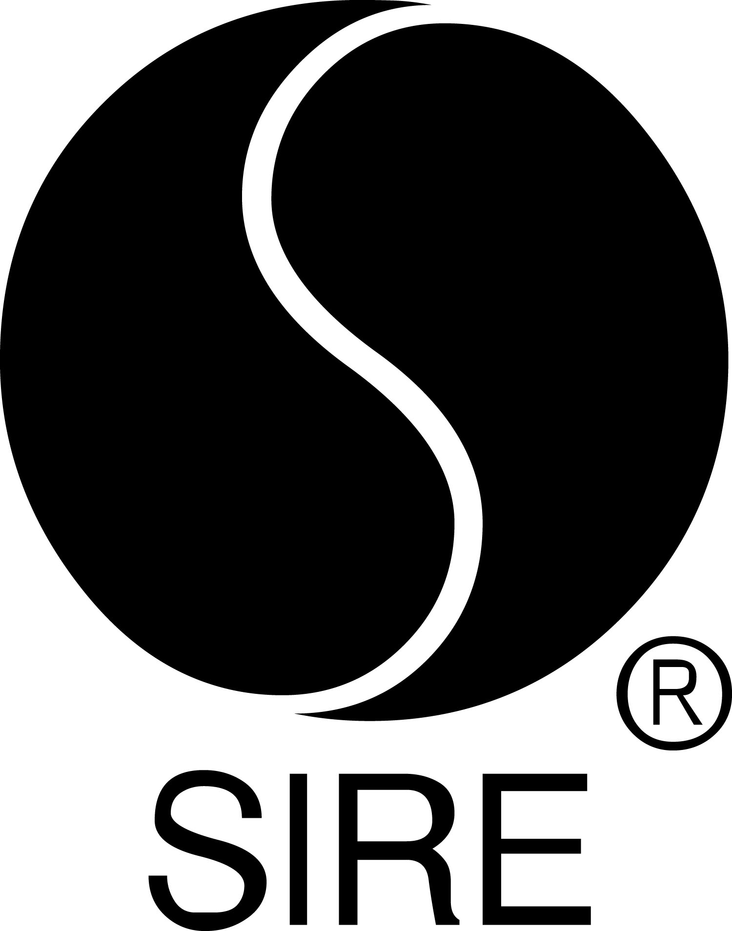

TEGAN AND SARA SHARE NEW SONG –
“Don’t Believe The Things They Tell You (They Lie)”

Track Is From New Album, Hey, I’m Just Like You, Out September 27 Via Sire

Tegan And Sara Visit The Late Show With Stephen Colbert On September 27 For A Chat and Performance

Fall Tour Launches With Sold-Out Shows Across the U.S. and Canada

High School, Tegan And Sara’s First Memoir, Out September 24

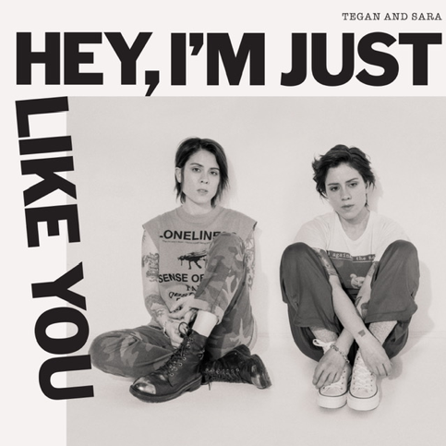

September 20, 2019 (Los Angeles, CA) – Ramping up for the September 27 release of Hey, I’m Just Like You (Sire), Tegan and Sara shared a new song from the album today. “Don’t Believe The Things They Tell You (They Lie)” examines the layers of deceit that cloud even the closest of relationships. Listen to “Don’t Believe The Things They Tell You (They Lie)” HERE and view the lyric video HERE.

While revisiting their teen years for their first memoir, High School – which will be published on September 24 by MCD X FSG (USA) in hardcover, ebook and audiobook – Tegan and Sara discovered two cassette tapes containing their very first songs, written between the ages of 15 and 17. On Hey, I’m Just Like You, hailed as one of the most anticipated albums of the fall by Pitchfork, USA Today and Billboard, Tegan and Sara return to the songs contained on those 1990s cassettes with a contemporary production. They will perform a song – and discuss the album and book – when they visit The Late Show with Stephen Colbert next Friday, September 27.

Speaking about “Don’t Believe The Things They Tell You (They Lie),” Sara recalls, “Our mother tells a story about watching the 1980s television show ‘Punky Brewster’ with us when we were four years old. The episode’s morality tale focused on lying, and near the end of the show, she describes one of us climbing onto her back, sobbing into her neck and confessing a lie we’d told her earlier in the day. At 15, we started telling lies again, and we absolved ourselves constantly in the lyrics of our songs.”

Tegan and Sara will kick off a special acoustic, multi-dimensional tour with a sold-out show at Murmrr in Brooklyn, NY on Tuesday, September 24. This headline run is sold out. One dollar from every ticket sold on the tour will benefit the Tegan and Sara Foundation, which fights for health, economic justice, and representation for LGBTQ girls and women. See below for itinerary and visit teganandsara.com for additional information.

Fans who pre-order Hey, I’m Just Like You in digital format will instantly receive the first single, “I’ll Be Back Someday” plus “Don’t Believe The Things They Tell You (They Lie)” and the title track, “Hey, I’m Just Like You.” Check out the 90’s vibes of the official video for “I’ll Be Back Someday” HERE. TIME praised the song’s “punk-rock insistence and straightforward lyricism that’s still prescient.”
Rolling Stone – relishing the “double whammy” of the album and the memoir – said, “Tegan and Sara’s debut memoir is a lot like their songs: complexly intimate, smartly crafted and packing a subtle emotional wallop.” Pre-order High School HERE.
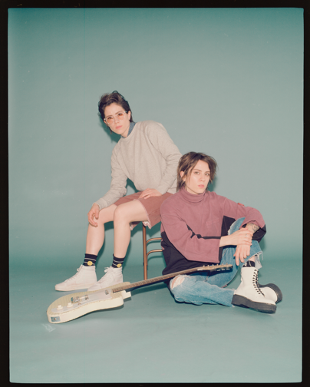
(Photo credit: Trevor Brady)

# # #

For further information about Tegan and Sara, contact:
Bobbie Gale / Warner Records
818-953-3692 / bobbie.gale@warnerrecords.com

For further information about book, contact:
Chloe Texier-Rose / FARRAR, STRAUS & GIROUX
212-206-5306 / chloe.texier-rose@fsgbooks.com

Digital Assets:
Download / stream “Don’t Believe The Things They Tell You (They Lie)” HERE
View lyric video HERE
Download hi-res album cover art HERE
Download hi-res Tegan and Sara photo HERE
Pre-order Hey, I’m Just Like You HERE
Tour information HERE
Pre-order (book) High School HERE
Images for book cover HERE
Find out more about the Tegan and Sara Foundation HERE

Follow Tegan and Sara:

Press materials:
http://press.warnerrecords.com/teganandsara

