U.K. INDIE POP ARTIST CAVETOWN SHARES NEW LIVE ALBUM,
LIVE AT HOXTON HALL

WATCH NEW “BOYS WILL BE BUGS” VIDEO HERE

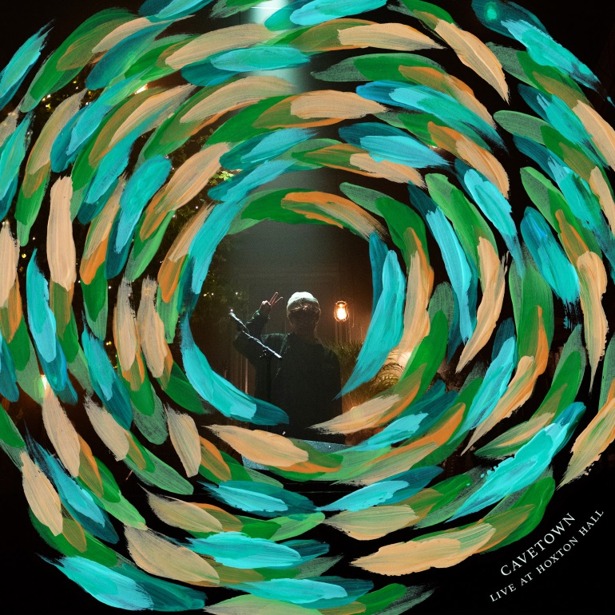

November 29, 2019 (Los Angeles, CA) – 20-year-old U.K. singer/songwriter, producer and multi-instrumentalist Cavetown shares his new live album, Live At Hoxton Hall today via Sire Records. Recorded throughout Cavetown’s three-night sold-out headline run at Hoxton Hall in London earlier this year, the new album features 13 live versions of fan-favorites, including “Home,” “Boys Will Be Bugs,” “Lemon Boy,” and “Green.” A new live video for “Boys Will Be Bugs” also releases today.

Listen/Share Live at Hoxton Hall HERE
Watch/Share “Boys Will Be Bugs” Video HERE

Since signing with Sire Records earlier this year, Cavetown has shared a number of new tracks, most recently including “Things That Make It Warm” and “Telescope.” He also performed on Last Call With Carson Daly, Reading & Leeds, and just wrapped a massive headline tour across North America ahead of another big run across the UK/Europe, Australia, and New Zealand. See upcoming dates below.

Starting from his humble beginnings as a 15-year old releasing homemade music on Youtube, Cavetown has amassed an enormous and committed following, consisting of nearly 3M monthly Spotify listeners and more than 1M Youtube subscribers with 110M video views across the platform. His devoted and ever-growing fanbase has built and nurtured their own underground grassroots community centered around his music, lining up for hours ahead of shows, coordinating homemade art projects, and bringing their own kazoos to play along with him, made all the more moving by how organically it’s developed over the years.

In 2018, Cavetown self-released his full-length debut Lemon Boy, which saw breakout success with its title track that’s racked up more than 30M Spotify streams and nearly 10M YouTube views. His most recent release, Animal Kingdom, is a digital mixtape series that features new songs, covers and re-imaginings of catalog material each month along with a song from a friend or peer that he’s had a hand in creating.

For more info on Cavetown, click here.

Live At Hoxton Hall Tracklisting
- Green
- 888
- Juliet
- Advice
- Dear
- Home
- Feb 14
- Things That Make It Warm
- Devil Town
- Lemon Boy
- Talk To Me
- Just Add Water
- Boys Will Be Bugs

Upcoming International Headline Tour Dates
Dec. 1 – Southampton, UK – Engine Roomsˆ *SOLD OUT*
Dec. 2 – Birmingham, UK – 02 Academyˆ *SOLD OUT*
Dec. 3 – Norwich, UK – Epicˆ *SOLD OUT*
Dec. 5 – Leeds, UK – Brudenell Social Club (Main Room)ˆ *SOLD OUT*
Dec. 6 – Glasgow, UK – The Garage° *SOLD OUT*
Dec. 7 – Manchester, UK – Manchester Academy 2° *SOLD OUT*
Dec. 8 – Dublin, IE – Dublin Academy Green Room° *SOLD OUT*
Dec. 10 – Bristol, UK – The Fleece° *SOLD OUT*
Dec. 12 – London, UK – Electric Ballroom° *SOLD OUT*
Jan. 15 – Melbourne, AU – The Evelyn Hotel *SOLD OUT*
Jan. 16 – Marrickville, AU – The Factory Theatre *SOLD OUT*
Jan. 17 – Brisbane, AU – The Triffid *SOLD OUT*
Jan. 19 – Auckland, NZ – The Tuning Fork *SOLD OUT*
Feb. 20 – Dublin, Ireland – The Academy *SOLD OUT*
Feb. 21 – Dublin, Ireland – The Academy
Feb. 23 – Belfast, UK – Oh Yeah Music Centre *SOLD OUT*
Feb. 24 – Glasgow, UK – SWG3 Studio Warehouse
Feb. 26 – Manchester, UK – O2 Ritz Manchester
Feb. 27 – Birmingham, UK – O2 Institute
Feb. 29 – London, UK – O2 Shepherd’s Bush Empire
March 2 – Cologne, DE – Luxor
March 3 – Copenhagen, DK – Vega
March 5 – Hamburg, DE – Mojo Club
March 6 – Berlin, DE – Bi Nuu
March 7 – Nijmegen, NL – Doornroosje
March 8 – Amsterdam, NL – Melkweg
March 9 – Brussels, BE – Le Botanique
April 11 – Stuttgart, DE – Im Wizemann
April 12 – Zurich, CH – Exil
April 14 – Milan, IT – Circolo Magnolia
April 15 – Munich, DE – Strom
April 17 – Salzberg, AT – Rockhouse Salzburg
April 18 – Budapest, DE – Akvarium Klub
April 20 – Wasaw, PL – Stodola
April 22 – Kiev, UA – ‘Atlas
April 24 – Moscow, RU – 1930 Moscow
April 25 – St. Petersburg, RU – Kosmonavt

ˆ = with mxmtoon + Simi
° = with mxmtoon + spookyghostboy

###

For further information, contact:
National: Jaime Rosenberg / Jaime.Rosenberg@warnerrecords.com
Regional/Tour Press: Patrice Compere / Patrice.Compere@warnerrecords.com

Follow Cavetown:
Website: www.cave.town
Facebook: Facebook.com/CavetownBand
Twitter: @Cavetown
Instagram: Instagram.com/lemon.socks
YouTube: Youtube.com/c/cavetown

Press materials:
sirerecords.com/press/cavetown

