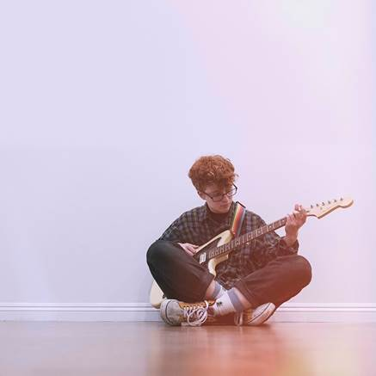

**LISTEN: CAVETOWN RELEASES NEW SONG “FEB 14” ALONGSIDE LIVE VIDEO FROM HOXTON HALL**

20-year-old U.K. singer/songwriter, producer, and multi-instrumentalist Cavetown just shared his new song [“Feb 14”](https://cvt.lnk.to/feb14) today on Sire Records. The release is accompanied by an intimate live video filmed at London’s Hoxton Hall, where Cavetown performed three sold-out shows earlier this year.

Cavetown is about to hit the road again, where he has a ton of sold-out headline dates through the end of the year in North America, Europe and the U.K. He recently added a second night at Webster Hall in New York (as well as in Boston and Chicago). Check out a full list of dates below.

For more info on Cavetown, click [here](https://www.sirerecords.com/press/cavetown).

**Listen to “Feb 14”** [**HERE**](https://cvt.lnk.to/feb14)

**Watch “Feb 14” Live Video** **[HERE](https://cvt.lnk.to/feb14video)**

**Upcoming Headline Tour Dates**

Aug. 9 – Amsterdam, NL – Melkweg Oz **\*SOLD OUT\***

Aug. 10 – Frankfurt, DE – Zoom Frankfurt **\*SOLD OUT\***

Aug. 12 – Wien, AT – Flex **\*SOLD OUT\***

Aug. 13 – Budapest, HU – Hajogyari Sziget

Aug. 14 – Praha 7, CZ – Cross Club

Aug. 15 – Warszawa, PL – Hydrozagadka**\*SOLD OUT\***

Aug. 16 – Leipzig, DE – Naumanns **\*SOLD OUT\***

Aug. 23 – Wetherby, UK – Reading & Leeds

Aug. 24 – Portsmouth, UK – Victorious Festival

Aug. 25 – Reading, UK – Reading & Leeds

Oct. 2 – Ithaca, NY – The Haunt

Oct. 3 – Toronto, ON – Opera House **\*SOLD OUT\***

Oct. 4 – Columbus, OH – Athenaum Theatre

Oct. 5 – Chicago, IL – Thalia Hall ***(SECOND NIGHT ADDED!)***

Oct. 6 – Chicago, IL – The Metro **\*SOLD OUT\***

Oct. 8 – St. Louis, MO – Delmar Hall

Oct. 9 – Lawrence, KS – The Granada Theater

Oct. 11 – Denver, CO – Ogden Theatre

Oct. 12 – Salt Lake City, UT – The Complex

Oct. 14 – Portland, OR – Wonder Ballroom **\*SOLD OUT\***

Oct. 15 – Vancouver, BC – Venue **\*SOLD OUT\***

Oct. 16 – Seattle, WA – The Showbox **\*SOLD OUT\***

Oct. 18 – San Francisco, CA – Regency Ballroom

Oct. 19 – Santa Ana, CA – The Observatory

Oct. 20 – Los Angeles, CA – The Fonda Theatre **\*SOLD OUT\***

Oct. 22 – San Diego, CA – Music Box

Oct. 23 – Phoenix, AZ – Crescent Ballroom **\*SOLD OUT\***

Oct. 25 – Austin, TX – Emo’s

Oct. 26 – Houston, TX – White Oak Music Hall

Oct. 27 – Dallas, TX – The Ganada Theater

Oct. 29 – Nashville, TN – Basement East **\*SOLD OUT\***

Oct. 30 – Charlotte, NC – The Underground

Nov. 1 – Richmond, VA – Broadberry **\*SOLD OUT\***

Nov. 2 – Philadelphia, PA – TLA **\*SOLD OUT\***

Nov. 3 – Asbury Park, NJ – House of Independents

Nov. 4 – Washington, DC – 9:30 Club

Nov. 6 – Boston, MA – The Royale ***(SECOND NIGHT ADDED!)***

Nov. 7 – Boston, MA – The Royale **\*SOLD OUT\***

Nov. 8 – New York, NY – Webster Hall **\*SOLD OUT\***

Nov. 9 – New York, NY – Webster Hall***(SECOND NIGHT ADDED!)***

Dec. 1 – Southampton, UK – Engine Roomsˆ **\*SOLD OUT\***

Dec. 2 – Birmingam, UK – 02 Academyˆ **\*SOLD OUT\***

Dec. 3 – Norwich, UK – Epicˆ

Dec. 5 – Leeds, UK – Brudenell Social Club (Main Room)ˆ **\*SOLD OUT\***

Dec. 6 – Glasgow, UK – The Garage° **\*SOLD OUT\***

Dec. 7 – Manchester, UK – Manchester Academy 2° **\*SOLD OUT\***

Dec. 8 – Dublin, IE – Dublin Academy Green Room° **\*SOLD OUT\***

Dec. 10 – Bristol, UK – The Fleece° **\*SOLD OUT\***

Dec. 12 – London, UK – Electric Ballroom° **\*SOLD OUT\***

Feb. 21 – Dublin, Ireland – The Academy

Feb. 23 – Belfast, UK – Oh Yeah Music Centre

Feb. 24 – Glasgow, UK – SWG3 Studio Warehouse

Feb. 26 – Manchester, UK – O2 Ritz Manchester

Feb. 27 – Birmingham, UK – O2 Institute

Feb. 29 – London, UK – O2 Shepherd’s Bush Empire

ˆ = with Simi

° = with spookyghostboy