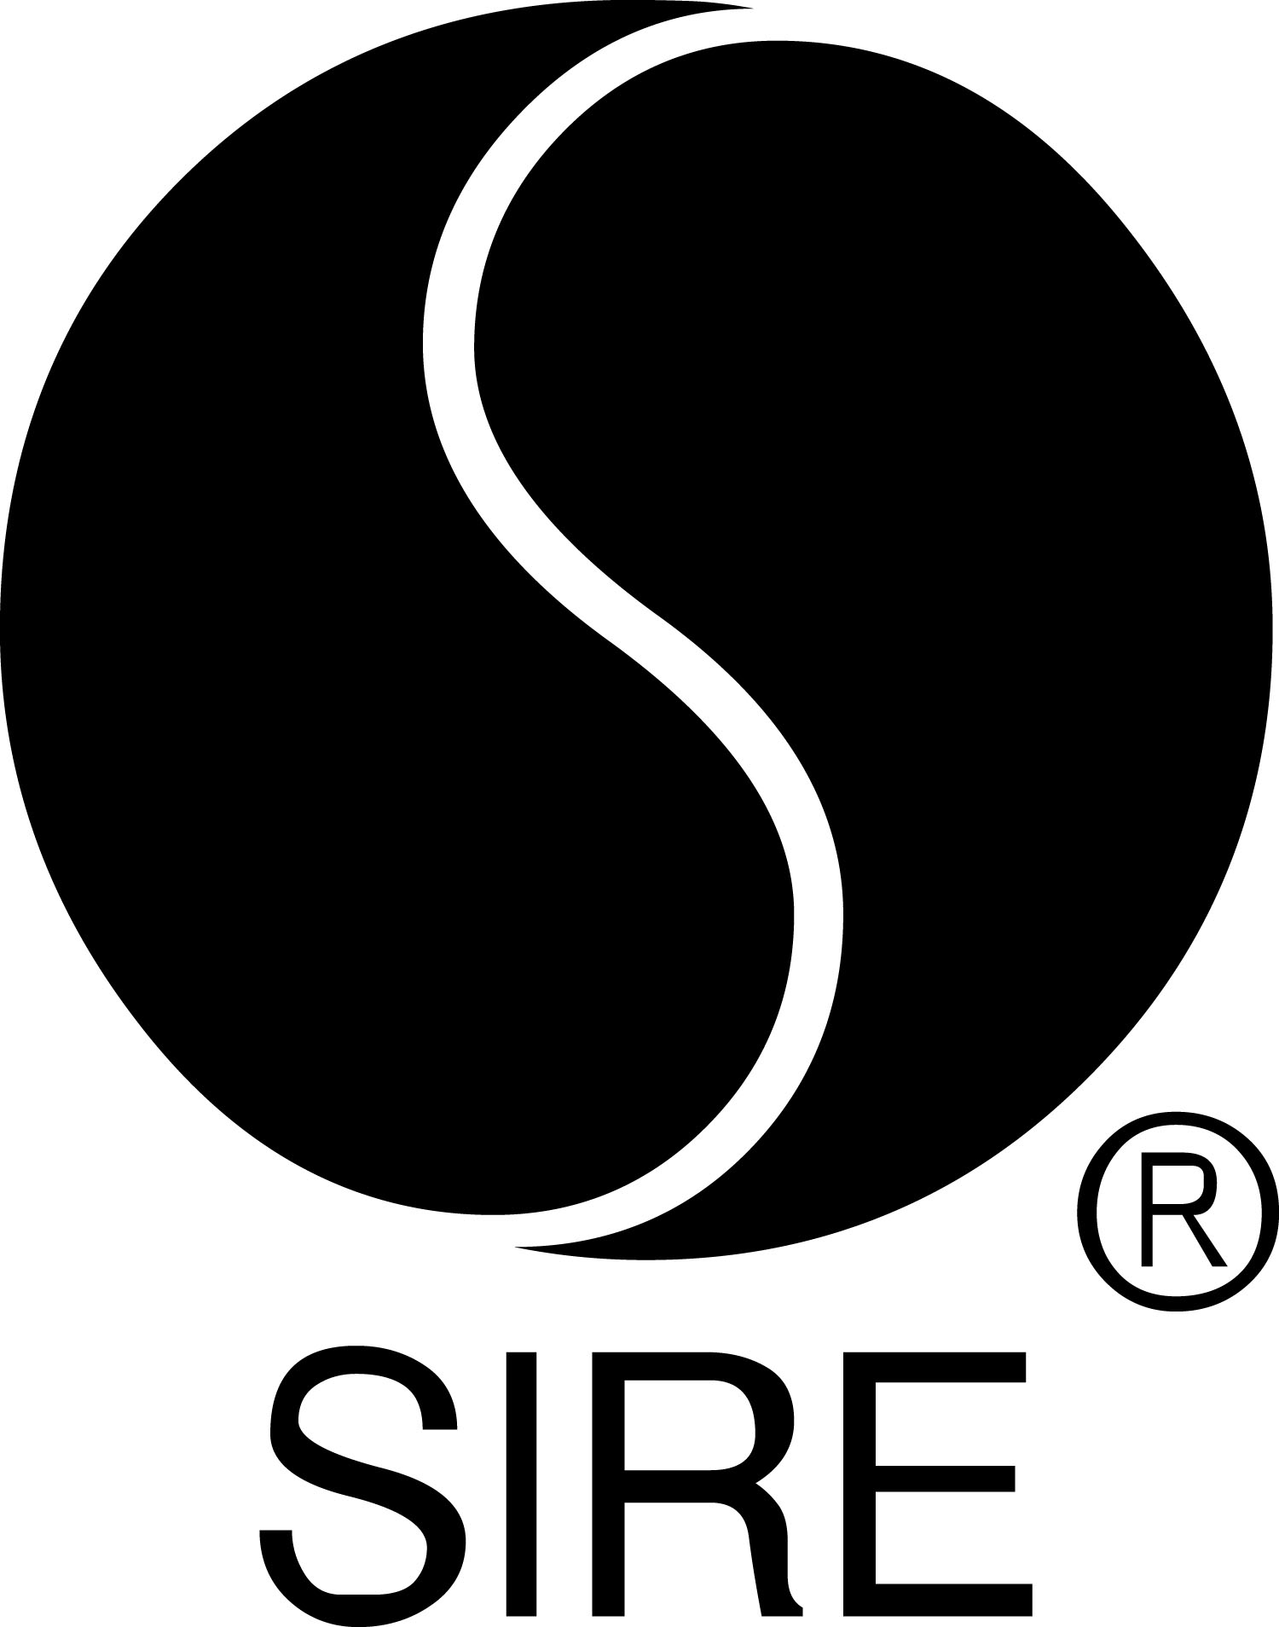

BRYCE VINE SHARES OFFICIAL VIDEO FOR “LA LA LAND” (FT. YG)

Directed By James Larese, Clip Features Vine, YG And Melanie Iglesias

View HERE

“La La Land” Launches As #1 Most Added Song At Pop Radio,

#3 Most Added At Rhythm, Already Charting Inside Top 40 at Both Formats

Track Follows Vine’s Platinum-Certified Hit “Drew Barrymore”

“[‘La La Land’ is] a classic Cali summer anthem.”
– NYLON

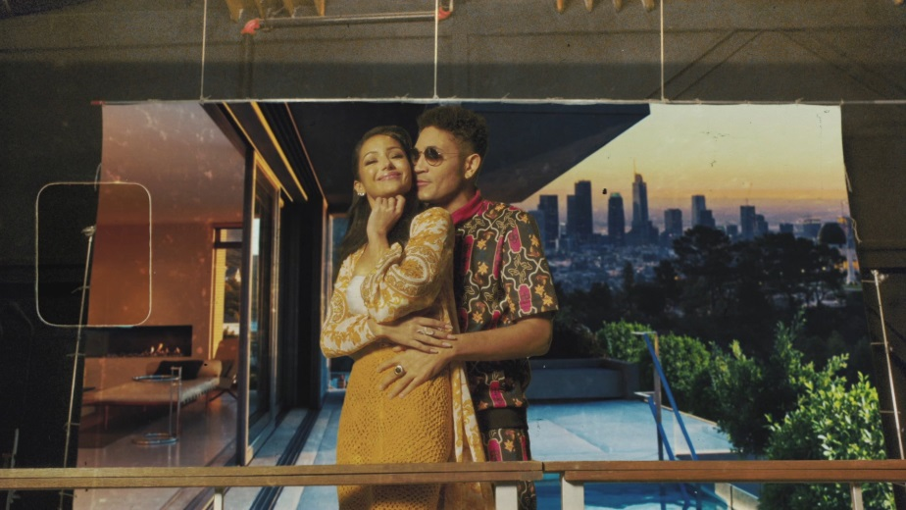

April 4, 2019 (Los Angeles, CA) — The video for “La La Land” – Bryce Vine’s follow-up to the Platinum-certified hit “Drew Barrymore” – was released today and can be viewed HERE. Directed by James Larese (Eminem, Bishop Briggs), it features Vine alongside multi-Platinum, Compton-based rapper YG, actress/model Melanie Iglesias (“Guy Code,” “Girl Code”) and one of the rehabilitated pups from the charitable organization Road Dogs & Rescue. With a satiric edge and a tip of the hat to classic filmmakers like Wes Anderson and Quentin Tarantino, the bold, vibrant video unfolds across a series of what appear to be quintessential L.A. locations – but the line between real and artificial quickly blurs in the town Vine calls home.

In its first week at radio, “La La Land” (ft. YG) was the #1 Most Added song at Top 40 and #3 Most Added at Rhythm, and is already charting inside the Top 40 at both formats. Spotify streams already exceed 4 million and the lyric video has nearly 1.5 million views. Vine penned the tongue-in-cheek, love-hate ode to Los Angeles with Sir Nolan, who produced both “La La Land” and “Drew Barrymore.”

NYLON hailed “La La Land” as “a classic Cali summer anthem” while Billboard noted, “The cheeky song is a clever send-up to Los Angeles culture.” Lyrical Lemonade said, “Vine’s music has a carefree and blissful tone to it, similar to the likes of rappers like Chance the Rapper and Kyle.” The track follows Vine’s Platinum-certified single “Drew Barrymore,” which was a Top 15 hit at both Pop and Rhythm radio. Bryce recently featured alongside Dan Caplen on Feder’s infectious 2018 single, “Control.” Heralded as a “rising star” by PEOPLE, Vine will release his debut album this summer.

Fresh off a sold-out 25-date headline run, Vine is currently playing a slew of college dates and will spend the summer playing a mixture of festivals (including Hangout, Prime and iHeart Radio in Las Vegas) and radio shows. Tickets are available now at brycevine.com. He recently wrapped up a sold-out North American headline tour.

UPCOMING FESTIVAL DATES
5/17-19 Gulf Shores, AL Hangout Music Fest
5/18 Raleigh, NC Prime Music Festival
9/21 Las Vegas, NV iHeart Radio Music Festival – Daytime Village

# # #

For further information on Bryce Vine, contact

Bobbie Gale at Warner Bros. Records publicity:
818-953-3692 / Bobbie.Gale@wbr.com

Ceri Roberts at Warner Bros. Records publicity:
212-707-2259 / Ceri.Roberts@wbr.com

Digital Assets:
Check out “La La Land” video HERE
Download / stream “La La Land” (ft. YG) HERE
View the lyric video HERE
Learn more about Road Dogs & Rescue HERE
Find tour information HERE
Listen to “Drew Barrymore” HERE

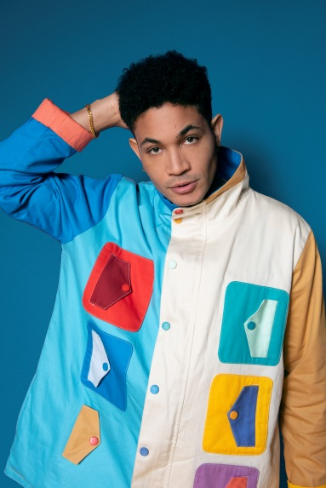
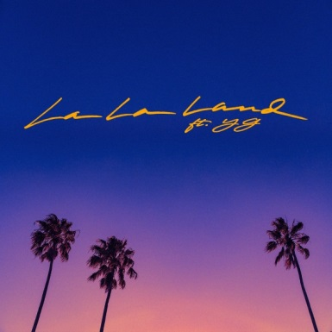
Follow Bryce Vine:
Website: https://www.brycevine.com
Facebook: https://www.facebook.com/brycevine/
Twitter: https://twitter.com/brycevine
Instagram: https://www.instagram.com/brycevine/?hl=en

Press Materials:
http://press.wbr.com/brycevine

