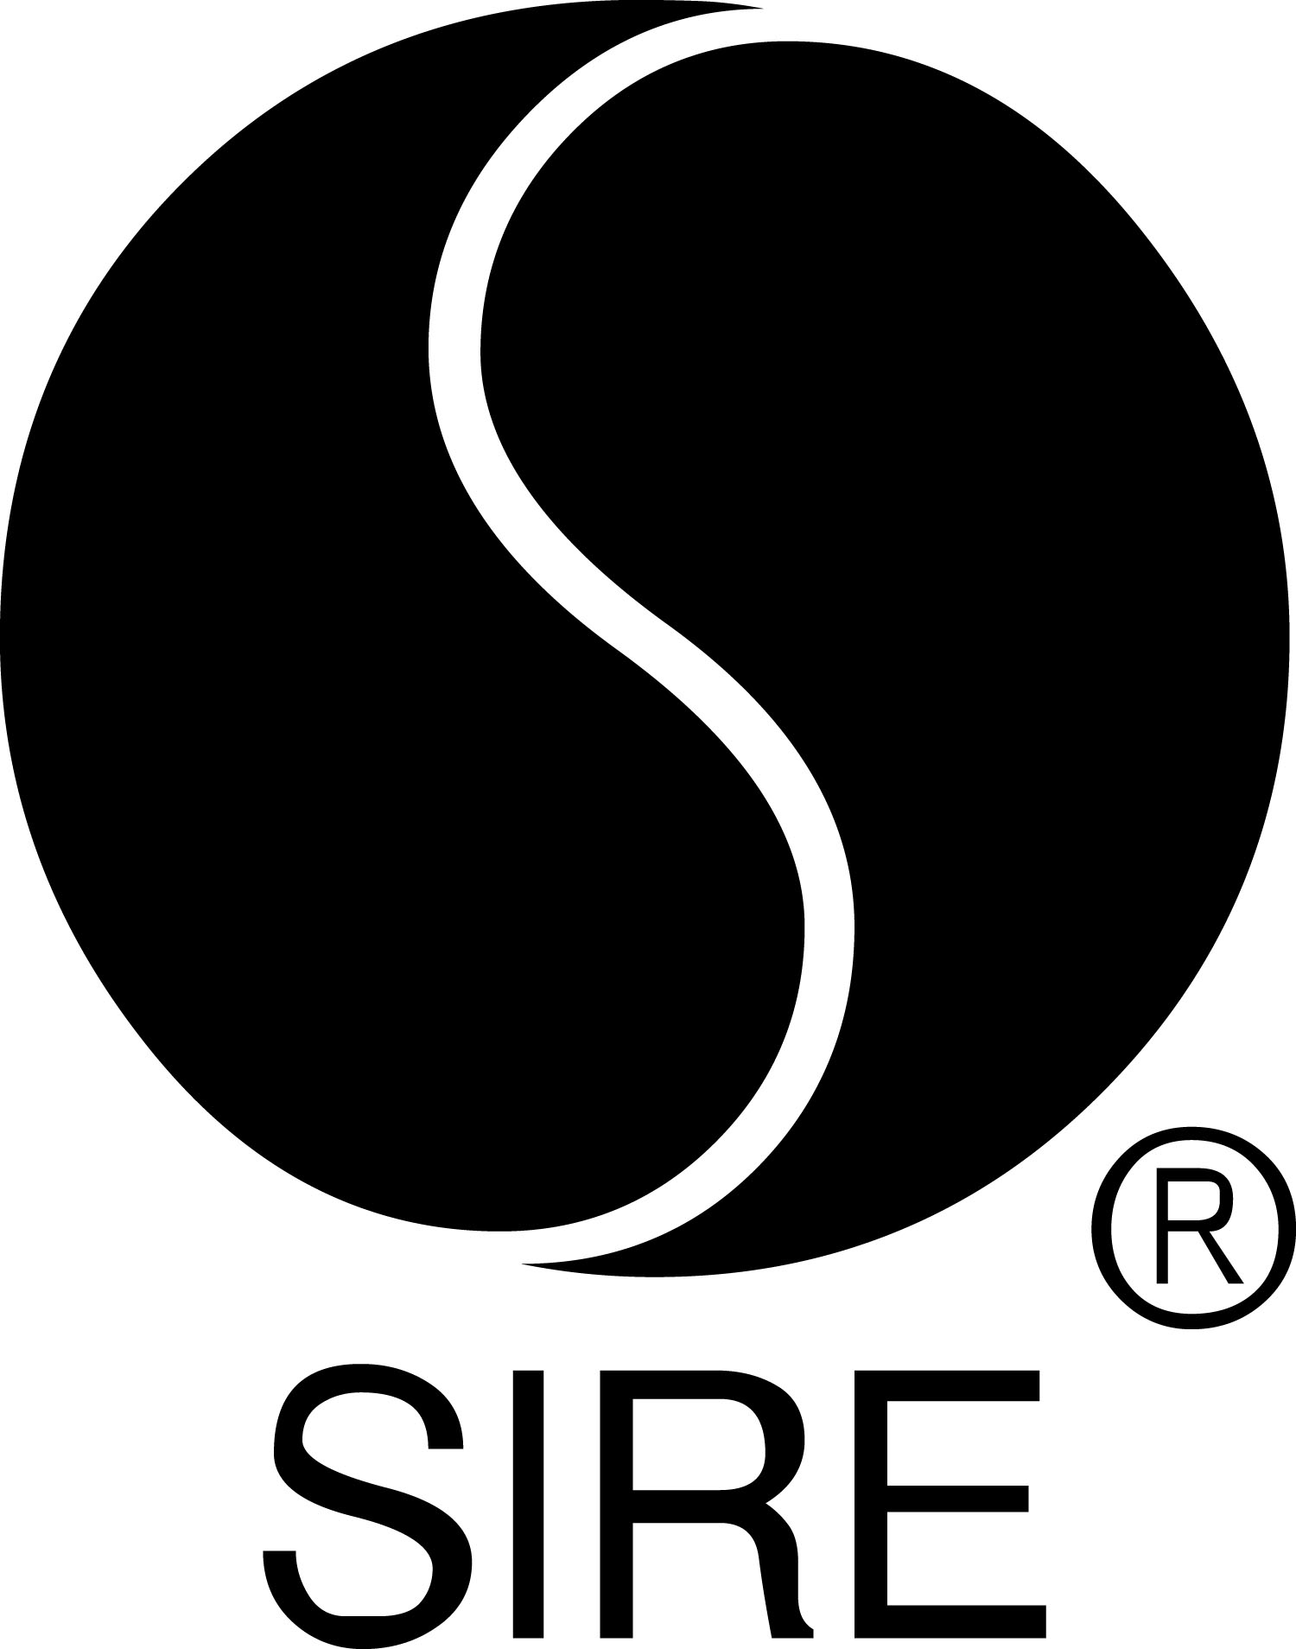

BRYCE VINE Performs “LA LA LAND” ON

Jimmy Kimmel Live! On June 5

Arkadi Remix Of “La La Land” (Ft. YG) Out Tonight

Listen HERE After Midnight

Performed “La La Land” This Week on The Wendy Williams Show

Watch HERE

“It’s time to add Bryce Vine to your summer playlist.” – PEOPLE

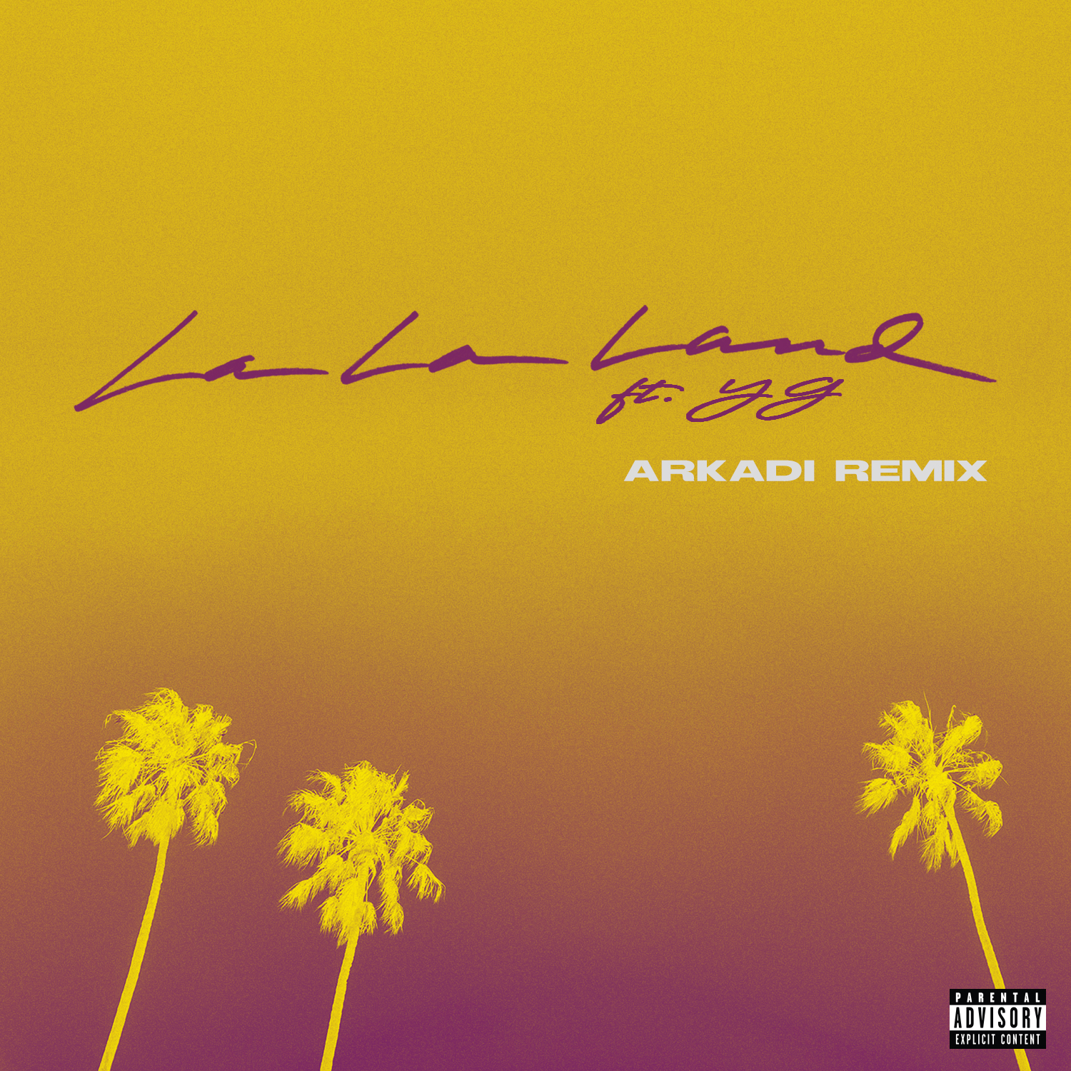

May 23, 2019 (Los Angeles, CA) — Tune in to Jimmy Kimmel Live! on Wednesday, June 5, to see Bryce Vine perform his new single, “La La Land.” Following his Platinum-certified hit “Drew Barrymore,” the recently released “La La Land” has already racked up more than 22 million cumulative streams. If you missed Vine performing on The Wendy Williams Show earlier this week, check out the segment HERE.

Tonight, Bryce Vine shares the vibrant Arkadi (Zedd, Backstreet Boys) remix of “La La Land,” which further amps up the track’s summertime vibe. Fans who purchase the Arkadi remix, available HERE tonight at midnight, will also receive the original version of the song.

“Drew Barrymore” was a top 15 hit at both Top 40 and Rhythm radio and “La La Land” is racing up the same charts, landing at #24 and #19 respectively on the current tallies. The official video, which was directed by James Larese (Eminem, Bishop Briggs), features Vine alongside multi-Platinum, Compton-based rapper YG, actress/model Melanie Iglesias (“Guy Code,” “Girl Code”) and a rehabilitated pup from the charitable organization Road Dogs & Rescue.

In this recent feature, PEOPLE said, “It’s time to add Bryce Vine to your summer playlist.” NYLON hailed “La La Land” as “a classic Cali summer anthem” while Billboard noted, “The cheeky song is a clever send-up to Los Angeles culture.”

After wrapping up a sold-out headline tour and a series of college dates, Vine is back on the road, playing a mixture of festivals (including iHeart Radio in Las Vegas) and radio shows. His debut album will be released this summer.

UPCOMING FESTIVAL DATES
5/25 Tampa, FL WFLZ / 93.3 FLZ’s Memorial Day Live
5/31 San Diego, CA KHTS / Channel 933’s Summer Kick Off Concert
6/1 Riverside, CA KGGI / Inland Empire Salsa Festival
6/7 Minneapolis, MN KDWB Star Party
6/8 Bethel Woods, NY WSPK / K104’s Kfest
6/14 Long Island, NY WBLI / Summer Jam
6/15 Long Island, NY WKTU /KTUphoria
6/16 Boston, MA WXKS / 40th Anniversary Kiss 108’s Kiss Concert
6/21 Indianapolis, IN WZPL / ZPL’s Birthday Bash
6/22 Chicago, IL B96 / Pepsi Summer Bash
6/23 Milwaukee, WI WXSS / 103.7 Kiss FM’s Kiss The Summer Hello
7/17 Las Vegas, NV KFRH / Flamingo GO POOL Dayclub
7/25 Sacramento, CA KSFM / K1025’s Summer Jam
8/24 Grand Rapids, MI Breakaway Music Festival
9/21 Las Vegas, NV iHeart Radio Music Festival – Daytime Village
10/5 Charlotte, NC Breakaway Music Festival
10/12 Nashville, TN Breakaway Music Festival

# # #

For further information on Bryce Vine, contact

Bobbie Gale at Warner Bros. Records publicity:
818-953-3692 / Bobbie.Gale@wbr.com

Ceri Roberts at Warner Bros. Records publicity:
212-707-2259 / Ceri.Roberts@wbr.com

Digital Assets:
Download / stream Arkadi mix of “La La Land” (ft. YG) HERE
Check out “La La Land” video HERE
See Vine’s performance on “The Wendy Williams Show” HERE
Read PEOPLE feature HERE
Find tour information HERE

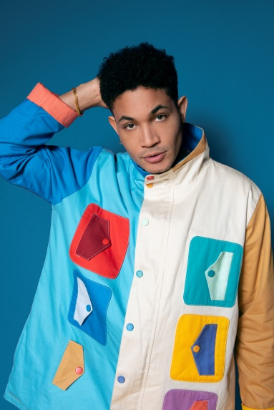
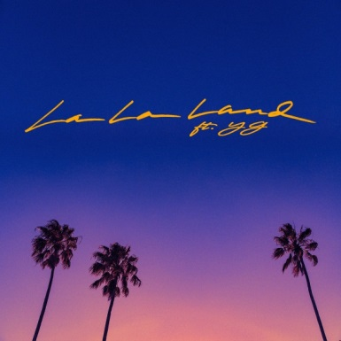
Follow Bryce Vine:
Website: https://www.brycevine.com
Facebook: https://www.facebook.com/brycevine/
Twitter: https://twitter.com/brycevine
Instagram: https://www.instagram.com/brycevine/?hl=en

Press Materials:

http://www.sirerecords.com/press/bryce-vine

