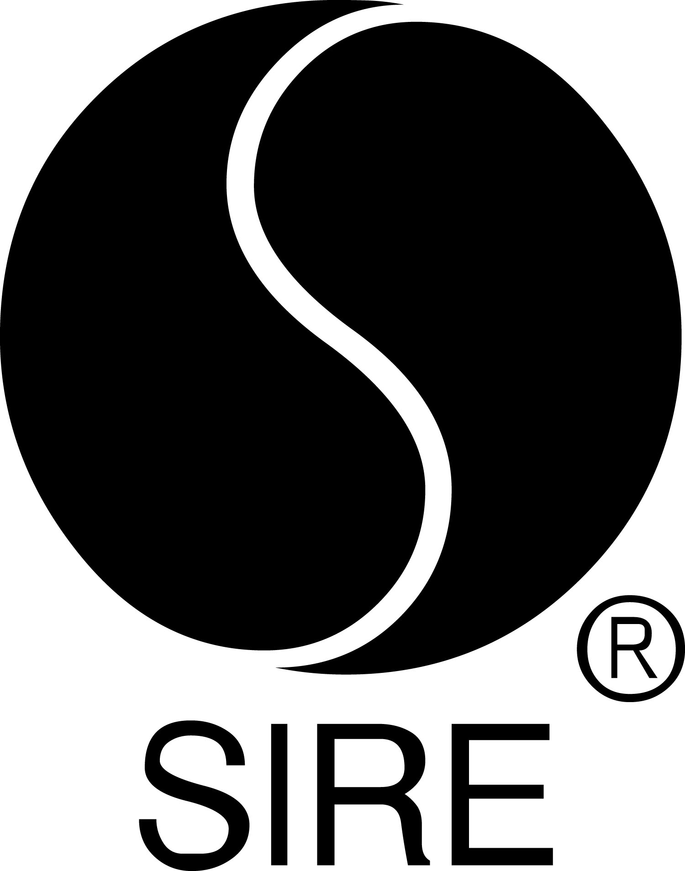

BRYCE VINE ANNOUNCES SPRING 2019 HEADLINE TOUR

Tickets On Sale Now at brycevine.com

“Drew Barrymore” Topped Charts in 2018, as a Top 15 Hit at

Top 40 and Rhythm Radio Formats

Vine Features on Feder’s New Single, “Control”
Stream HERE

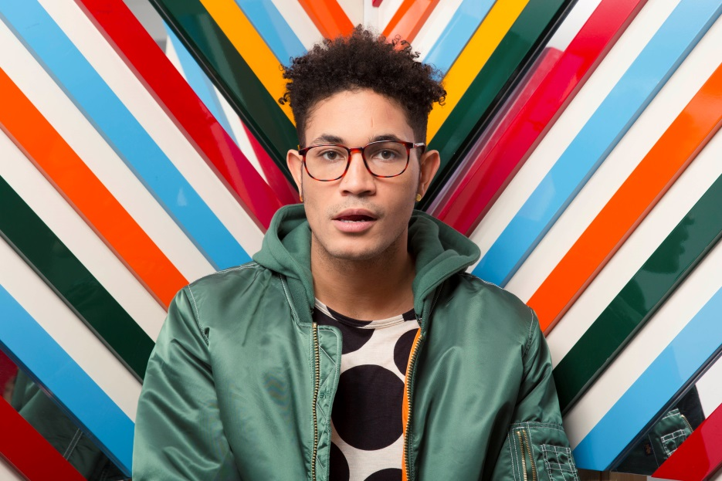

November 30, 2018 (Los Angeles, CA) — Building on the momentum of his breakout success in 2018, Bryce Vine will launch his first North American tour of 2019 at Gramercy in New York City on February 5. The headline run will include shows at Union Stage in Washington, DC (February 8), Chicago’s Lincoln Hall (February 15) and the legendary Troubadour in West Hollywood, CA (March 2). Tickets are available now at brycevine.com. See below for itinerary, and stay tuned for more dates to be announced soon. As revealed yesterday, Vine will also perform at the 2019 Hangout Music Fest in Gulf Shores, AL.

Hailed as a “rising star” by PEOPLE, Vine has had a stellar year, culminating with his hit single, “Drew Barrymore,” reaching the Top 15 hit at both Top 40 and Rhythm radio and accumulating over 137 million streams. He is featured alongside Dan Caplen on Feder’s infectious new single, “Control,” which was released last Friday. Rolling Stone calls the track “alluring” and calls out Vine’s vocal stylings as an “enticing drawl.” Stream “Control” HERE.

Vine is one of the noteworthy emerging artists featured on Pepsi’s The Sound Drop platform. Other 2018 highlights include performing “Drew Barrymore” on Late Night With Seth Meyers and the MTV Video Music Awards pre-show. He will kick off 2019 with a January 4 performance on Audience Network, which is available in 280 million homes.

TIME said, “Vine sounds like the definition of cool as he effortlessly switches between unhurried rap and R&B-infused singing.” VIBE observed, “You can’t put Bryce Vine in a box” while the LA Weekly noted, “His style is diverse and his lyrics are infused with a millennial’s social tribulations.”

2019 TOUR DATES
2/5 New York, NY Gramercy Theatre
2/6 Boston, MA Brighton Music Hall
2/8 Washington, DC Union Stage
2/10 Atlanta, GA The Masquerade – Hell
2/14 Detroit, MI The Shelter
2/15 Chicago, IL Lincoln Hall
2/17 St. Louis, MO The Ready Room
2/19 Madison, WI Majestic
2/21 Des Moines, IA Woolys
2/22 Minneapolis, MN Fine Line
2/23 Omaha, NE Waiting Room
2/24 Denver, CO Bluebird
2/28 San Diego, CA Soma
3/1 Santa Ana, CA Constellation Room
3/2 West Hollywood, CA Troubadour
3/3 Santa Barbara, CA Velvet Jones
3/5 Berkeley, CA Cornerstone
3/6 Sacramento, CA Harlows
3/8 Portland, OR Hawthorne
3/9 Seattle, WA Neumos
3/10 Vancouver, BC Venue
5/17-19 Gulf Shores, AL Hangout Music Fest

# # #

For further information on Bryce Vine, contact

Bobbie Gale at Warner Bros. Records publicity:
818-953-3692 / Bobbie.Gale@wbr.com

Ceri Roberts at Warner Bros. Records publicity:
212-707-2259 / Ceri.Roberts@wbr.com

Digital Assets:
Find tour information HERE
Listen to “Drew Barrymore” HERE
Stream “Control” HERE
Follow Bryce Vine:
Website: https://www.brycevine.com
Facebook: https://www.facebook.com/brycevine/
Twitter: https://twitter.com/brycevine
Instagram: https://www.instagram.com/brycevine/?hl=en

Press Materials:
http://press.wbr.com/brycevine

