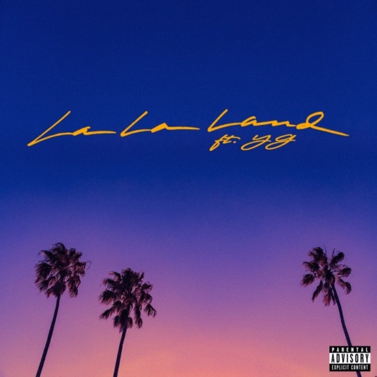
We wanted to share a new track with you from our fabulous BRYCE VINE called LA LA LAND which features fellow Angeleno, YG, and was co-written and produced by Sir Nolan. In true Bryce fashion, the song is a tongue in cheek, insta-ready, sing-a-long love letter to Los Angeles or is it?
SONG HERE
LYRIC VIDEO HERE
LA LA LAND is the follow up to Bryce’s “Drew Barrymore” single which was recently certified platinum.
Bryce is currently on a sold-out headline tour and will continue to tour this spring. Expect a fresh, fun and bold video for LA LA LAND soon with his debut full length record this summer.
Anything you need – just shout….
Bobbie & Ceri
Bobbie.Gale@wbr.com
Ceri.Roberts@wbr.com
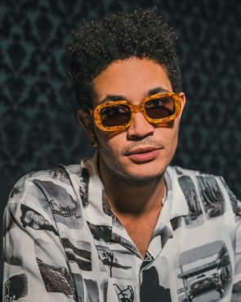
Follow Bryce Vine:
Website: https://www.brycevine.com
Facebook: https://www.facebook.com/brycevine/
Twitter: https://twitter.com/brycevine
Instagram: https://www.instagram.com/brycevine/?hl=en

