BRYCE VINE RELEASES MAJOR LABEL DEBUT CARNIVAL,
OUT NOW ON SIRE RECORDS

LISTEN HERE

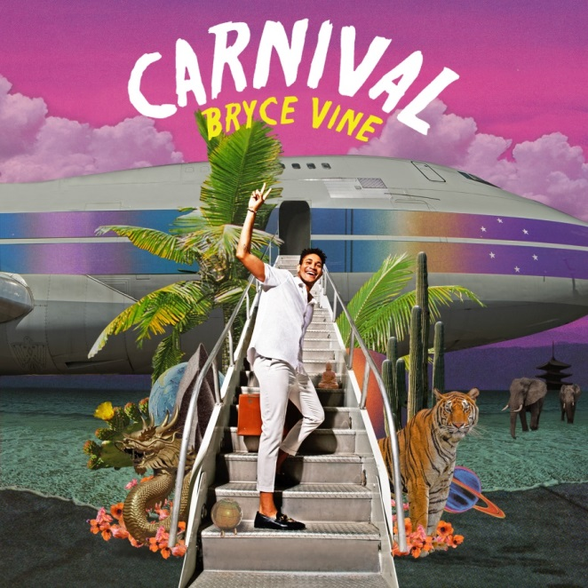
(hi-res album artwork HERE)

July 26, 2019 (Los Angeles, CA) – Bryce Vine has released his major label debut Carnival, available now on Sire Records. Carnival features current single “La La Land (feat. YG)” and the Platinum-certified hit “Drew Barrymore,” as well as six brand new songs. To celebrate release week, Vine is hitting the road for a string of headline dates, kicking off tomorrow, July 27, at The Fonda in Los Angeles and includes a stop at Webster Hall in New York on August 3.

CARNIVAL TRACKLIST:
- Classic and Perfect
- La La Land feat. YG
- Love is a Blessing
- Voicemail (Interlude)
- Drew Barrymore
- Deep In Shallow Water
- Love Me Hate Me
- Factory Love
- San Junipero
- Havana (Outro)

“Vine sounds like the definition of cool as he effortlessly switches between unhurried rap and R&B-infused singing.”
– TIME

“[His] smooth, unpretentious performance really sold us on Bryce as a breakout star.”
– Teen Vogue

“You can’t put Bryce Vine in a box.”
– VIBE

“Bryce Vine is infusing his hip-hop tunes with an alternative feel in ways that, well, actually rock.”
– Entertainment Weekly

“Vine’s music has a carefree and blissful tone to it, similar to the likes of rappers like Chance the Rapper and Kyle.”
– Lyrical Lemonade

MORE ABOUT BRYCE VINE:
Bryce Vine presents a genre-bending, East Coast-meets-West Coast sound all his own, drawn in equal parts from the bass-heavy reality rap influence of his father, the bright, pop sensibility of his mother, and a childhood spent between New York and L.A. His major label debut Carnival is filled with inspirations that run the gamut of the pop culture zeitgeist, lyrically referencing his favorite sci-fi TV shows, 90’s nostalgia and commentary on growing up in LA, while effortlessly fusing the punk spirit of Blink-182 with homages to Tupac and Outkast. Following the breakthrough success of the Platinum-certified “Drew Barrymore,” Bryce Vine has spent 2019 on sold out headline tours of the US while “La La Land (feat. YG)” follows the same trajectory as his first single. Vine has performed on Late Night with Seth Meyers, the MTV VMAs pre-show, The Wendy Williams Show, and Jimmy Kimmel Live!, and is on tour throughout the summer, with all dates and tickets available at brycevine.com.

UPCOMING TOUR DATES:

*7/27 Los Angeles, CA The Fonda Theatre (w/ opener Carlie Hanson)

*8/1 Washington, DC The Fillmore

*8/3 New York, NY Webster Hall

*8/4 Philadelphia, PA Theatre of Living Arts
8/24 Grand Rapids, MI Breakaway Music Festival
8/30-9/1 Seattle, Washington Bumbershoot
9/21 Las Vegas, NV iHeart Radio Music Festival Day Stage
10/5 Charlotte, NC Breakaway Music Festival
10/12 Nashville, TN Breakaway Music Festival
11/22-23 San Diego, CA Wonderfront Music Festival
*headline date

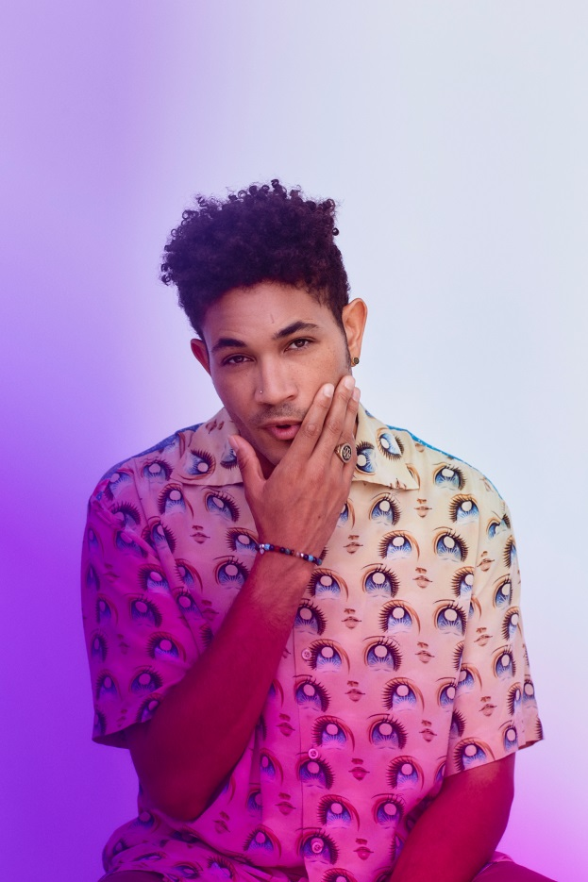
Photo Credit: Jonathan Weiner
(hi-res press photo HERE)

# # #

For further information on Bryce Vine, contact

Bobbie Gale at Warner Records:
818-953-3692 / Bobbie.Gale@warnerrecords.com

Ceri Roberts at Warner Records:
212-707-2259 / Ceri.Roberts@warnerrecords.com

For tour press, contact
Bre Flores at Warner Records:
818-953-3368 / Breanne.Flores@warnerrecords.com

Follow Bryce Vine:
Website | Facebook | Twitter | Instagram

Press Materials:

http://www.sirerecords.com/press/bryce-vine

