cid:image001.jpg@01D516F9.7D1B0C10

**U.K. INDIE POP ARTIST CAVETOWN SHARES NEW TRACK “TELESCOPE”**

**SOLD-OUT NORTH AMERICAN HEADLINE TOUR KICKS OFF OCTOBER 2**

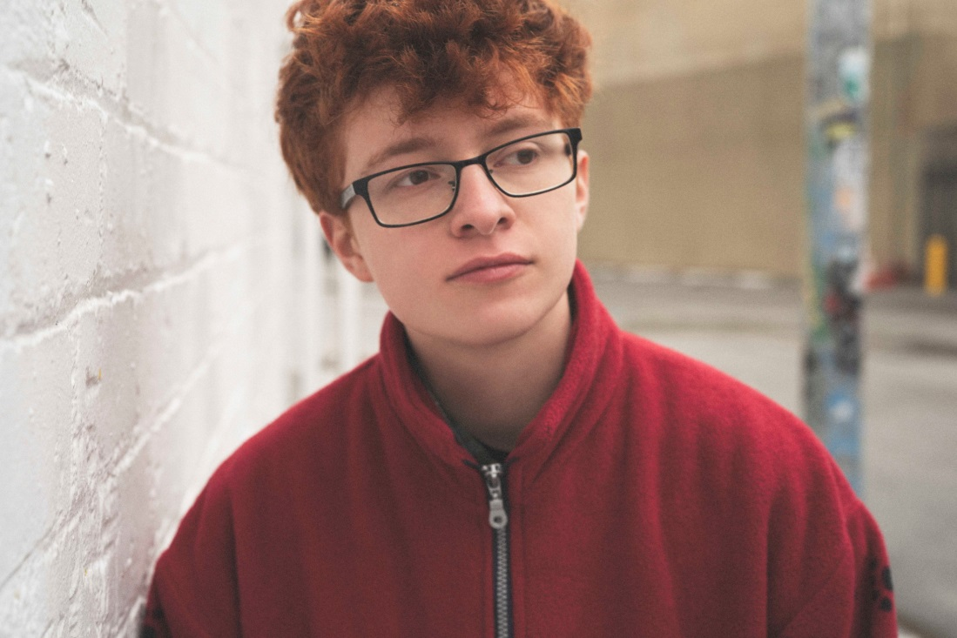

**September 13, 2019 (Los Angeles, CA) -** Cavetown has shared his new track, [“Telescope,”](https://cvt.lnk.to/telescope) today on Sire Records. This is the most recent release from the 20-year-old U.K. singer/songwriter, producer and multi-instrumentalist, who is gearing up for a nearly sold-out North American headlining tour this Fall, kicking off October 2 in Ithaca, NY. These are the latest in a series of sold-out worldwide tours across the U.S. and Europe, including multiple night residencies in London, Los Angeles and New York City.

**Listen to “Telescope”** [**HERE**](https://cvt.lnk.to/telescope)

Since Cavetown’s humble beginnings as a 15-year old releasing homemade music on Youtube, he has amassed an enormous and committed following, consisting of over 2.5M monthly Spotify listeners and 1M Youtube subscribers with over 100M video views across the platform. Earlier this year, Cavetown performed on [*Last Call With Carson Daly*](https://www.nbc.com/last-call-with-carson-daly/video/cavetown-this-is-home/3937864), Reading & Leeds, and most recently, three sold-out nights at London’s Hoxton Hall, where he taped his recently-released live video for [“Feb 14.”](https://www.youtube.com/watch?v=2AMnviRQfKg)

The son of a professional flautist and Cambridge University’s director of music, Robin Skinner — who’s performed under the name Cavetown since 2013 — has musical talent literally embedded in his DNA. At age 14, he started posting original songs and covers on YouTube alongside daily musings and behind-the-scenes vignettes, creating a barrier-free connection with his fans as they saw themselves in his music. His devoted and ever-growing fanbase has built and nurtured their own underground grassroots community centered around his music, lining up for hours ahead of shows, coordinating homemade art projects, and bringing their own kazoos to play along with him, made all the more moving by how organically it’s developed over the years.

In 2018, Cavetown self-released his full-length debut [*Lemon Boy*](https://open.spotify.com/album/2dJhTwaouxbcL2xjdw0zjK), which saw breakout success with its title track that’s racked up more than 24M Spotify streams and nearly 10M YouTube views. His most recent release, *Animal Kingdom*, is a digital mixtape series that features new songs, covers and re-imaginings of catalog material each month along with a song from a friend or peer that he’s had a hand in creating. He recently signed to Sire Records and will continue to release new music over the next several months.

For more info on Cavetown, click [here](https://www.sirerecords.com/press/cavetown).

**Upcoming US Headline Tour Dates**  
Oct. 2 – Ithaca, NY – The Haunt ^   
Oct. 3 – Toronto, ON – Opera House ^ **\*SOLD OUT\***  
Oct. 4 – Columbus, OH – Athenaum Theatre ^  
Oct. 5 – Chicago, IL – Thalia Hall ~ ***(SECOND NIGHT ADDED!)***  
Oct. 6 – Chicago, IL – The Metro ^ **\*SOLD OUT\***  
Oct. 8 – St. Louis, MO – Delmar Hall ^ **\*SOLD OUT\***  
Oct. 9 – Lawrence, KS – The Granada Theater ^  
Oct. 11 – Denver, CO – Ogden Theatre ^  
Oct. 12 – Salt Lake City, UT – The Complex ^  
Oct. 14 – Portland, OR – Wonder Ballroom # **\*SOLD OUT\***  
Oct. 15 – Vancouver, BC – Venue # **\*SOLD OUT\***  
Oct. 16 – Seattle, WA – The Showbox # **\*SOLD OUT\***  
Oct. 18 – San Francisco, CA – Regency Ballroom % **\*SOLD OUT\***  
Oct. 19 – Santa Ana, CA – The Observatory % **\*SOLD OUT\***  
Oct. 20 – Los Angeles, CA – The Fonda Theatre % **\*SOLD OUT\***  
Oct. 22 – San Diego, CA – Music Box %  
Oct. 23 – Phoenix, AZ – Crescent Ballroom % **\*SOLD OUT\***  
Oct. 25 – Austin, TX – Emo’s %  
Oct. 26 – Houston, TX – White Oak Music Hall %  
Oct. 27 – Dallas, TX – The Ganada Theater % **\*SOLD OUT\***  
Oct. 29 – Nashville, TN – Basement East ^ **\*SOLD OUT\***  
Oct. 30 – Charlotte, NC – The Underground ^ **\*SOLD OUT\***  
Nov. 1 – Richmond, VA – Broadberry ^ **\*SOLD OUT\***  
Nov. 2 – Philadelphia, PA – TLA & **\*SOLD OUT\***  
Nov. 3 – Asbury Park, NJ – House of Independents ^  
Nov. 4 – Washington, DC – 9:30 Club ^  
Nov. 6 – Boston, MA – The Royale ^ ***(SECOND NIGHT ADDED!)***  
Nov. 7 – Boston, MA – The Royale + **\*SOLD OUT\***  
Nov. 8 – New York, NY – Webster Hall ^ **\*SOLD OUT\***  
Nov. 9 – New York, NY – Webster Hall & ***(SECOND NIGHT ADDED!)***

ˆ = with Field Medic + spookyghostboy

~ = with Chloe Moriondo + Jackie Hayes

# = with Field Medic + Selfish Things

% = with Field Medic + Shannen Moser

& = with Chloe Moriondo + MICHELLE

+ = with Field Medic + MICHELLE

**Upcoming UK / EU Headline Tour Dates**Dec. 1 – Southampton, UK – Engine Roomsˆ **\*SOLD OUT\***  
Dec. 2 – Birmingam, UK – 02 Academyˆ **\*SOLD OUT\***  
Dec. 3 – Norwich, UK – Epicˆ  
Dec. 5 – Leeds, UK – Brudenell Social Club (Main Room)ˆ **\*SOLD OUT\***  
Dec. 6 – Glasgow, UK – The Garage° **\*SOLD OUT\***  
Dec. 7 – Manchester, UK – Manchester Academy 2° **\*SOLD OUT\***  
Dec. 8 – Dublin, IE – Dublin Academy Green Room° **\*SOLD OUT\***  
Dec. 10 – Bristol, UK – The Fleece° **\*SOLD OUT\***  
Dec. 12 – London, UK – Electric Ballroom° **\*SOLD OUT\***  
Feb. 21 – Dublin, Ireland – The Academy  
Feb. 23 – Belfast, UK – Oh Yeah Music Centre  
Feb. 24 – Glasgow, UK – SWG3 Studio Warehouse  
Feb. 26 – Manchester, UK – O2 Ritz Manchester  
Feb. 27 – Birmingham, UK – O2 Institute  
Feb. 29 – London, UK – O2 Shepherd’s Bush Empire

ˆ = with mxmtoon + Simi  
° = with mxmtoon + spookyghostboy

###

**For further information, contact:**

National: Jaime Rosenberg / [Jaime.Rosenberg@warnerrecords.com](mailto:Jaime.Rosenberg@warnerrecords.com)

Regional/Tour Press: Patrice Compere / [Patrice.Compere@warnerrecords.com](mailto:Patrice.Compere@warnerrecords.com)

**Follow Cavetown:**

Website: [www.cave.town](http://www.cave.town/)

Facebook: Facebook.com/CavetownBand

Twitter: [@Cavetown](https://twitter.com/cavetown)

Instagram: [Instagram.com/lemon.socks](https://www.instagram.com/lemon.socks/)

YouTube: [Youtube.com/c/cavetown](https://www.youtube.com/c/cavetown)

**Press materials:**

<http://www.sirerecords.com/press/cavetown>