U.K. INDIE POP ARTIST CAVETOWN RELEASES
NEW SINGLE “SWEET TOOTH” (LISTEN HERE)

HIGHLY-ANTICIPATED NEW ALBUM SLEEPYHEAD OUT MARCH 27

JUST ANNOUNCED: NEW YORK & PHILADELPHIA UNDERPLAY SHOWS

(Photo Credit: Emily Heath)

February 14, 2020 (Los Angeles, CA) – U.K. indie pop artist Cavetown has announced his major label debut album, SLEEPYHEAD, out March 27 on Sire Records. Written, recorded, produced, mixed and mastered by Cavetown himself in the bedroom of his new London apartment, the 11-song collection includes fan favorites “Things That Make It Warm,” “Feb 14,” “Telescope,” as well as 8 new tracks, including “Snail” featuring Chloe Moriondo and lead single, “Sweet Tooth,” which is out today. To celebrate, Cavetown just announced two album release underplay shows in New York City and Philadelphia next month, following a slew of sold-out headline dates across North America, UK/Europe, Australia, and New Zealand. Dates are listed below.

LISTEN/SHARE “SWEET TOOTH” HERE
PRE-ORDER SLEEPYHEAD HERE

Cavetown distilled his energy on SLEEPYHEAD into what really moves fans: the songs themselves, occasionally lighthearted, largely poignant – but always authentically him. He explains, “Ultimately, everyone has the same struggles when we boil it down, even if the details are different. That’s what I’m trying to get across with my music. It’s basically just me telling myself what I need to hear.”

Since launching Cavetown at age 14, the singer – real name Robin Skinner – has racked up 250 million Spotify plays and 1.15 million YouTube subscribers. He did so not with a viral hit or easy gimmicks, but rather pure heart, filling his YouTube channel with day-in-the-life, behind-the-scenes vignettes and covers that allowed fans a barrier-free inside look at his life. Coupled with his original, self-recorded music, Skinner’s unassuming-yet-captivating personality took the internet by storm, catapulting him to millions of streams and subscribers and stages around the world, including recent sold-out headline performances at venues like Los Angeles’ Fonda Theatre, New York City’s Webster Hall and London’s Shepherd’s Bush Empire, as well as Reading & Leeds, Shaky Knees, and TRNSMT Festival. His performances, like his music, are an inspiring celebration of life in all its forms, as fans come from points near and far to laugh, cry and revel in the deep-rooted sense of connectivity found in the songs. Billboard recently profiled the phenomenon around Cavetown in “Welcome to Cavetown's World, A Place That Feels Like Home” – read it here.

Since signing with Sire Records last year, Cavetown has shared his heartwarming cover of Randy Newman’s “You’ve Got A Friend In Me” as well as live album Live At Hoxton Hall, recorded throughout his three-night sold-out headline run at Hoxton Hall in London. In 2018, he self-released his full-length debut Lemon Boy, which saw breakout success with its title track that has racked up more than 30M Spotify streams and nearly 10M YouTube views. He also co-wrote and produced mxmtoon’s critically-acclaimed 2019 album The Masquerade, and is currently working with Chloe Moriondo on her forthcoming major-label debut.

“Sweet Tooth” Single Cover (hand-painted by Robin Skinner)
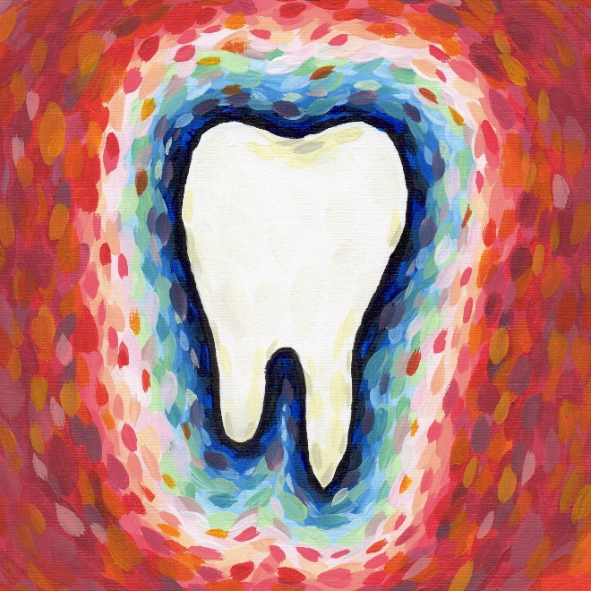

SLEEPYHEAD Cover Art (hand-painted by Robin Skinner)

SLEEPYHEAD Tracklisting
- Sweet Tooth
- For You
- Telescope
- Feb 14
- Pyjama Pants
- Trying
- Things That Make It Warm
- Snail (with Chloe Moriondo)
- Wishing Well
- I Miss My Mum
- Empty Bed

Upcoming Headline Tour Dates
Feb. 20 – Dublin, Ireland – The Academy *SOLD OUT*
Feb. 21 – Dublin, Ireland – The Academy *SOLD OUT*
Feb. 23 – Belfast, UK – Oh Yeah Music Centre *SOLD OUT*
Feb. 24 – Glasgow, UK – SWG3 Studio Warehouse *SOLD OUT*
Feb. 26 – Manchester, UK – O2 Ritz Manchester *SOLD OUT*
Feb. 27 – Birmingham, UK – O2 Institute
Feb. 29 – London, UK – O2 Shepherd’s Bush Empire *SOLD OUT*
March 2 – Cologne, DE – Luxor *SOLD OUT*
March 3 – Copenhagen, DK – Vega *SOLD OUT*
March 5 – Hamburg, DE – Mojo Club
March 6 – Berlin, DE – Bi Nuu *SOLD OUT*
March 7 – Nijmegen, NL – Doornroosje *SOLD OUT*
March 8 – Amsterdam, NL – Melkweg
March 9 – Brussels, BE – Le Botanique
April 9 – London, UK – Electric Ballroom *SOLD OUT* (rescheduled)
April 11 – Stuttgart, DE – Im Wizemann
April 12 – Zurich, CH – Exil
April 14 – Milan, IT – Circolo Magnolia
April 15 – Munich, DE – Strom
April 17 – Salzberg, AT – Rockhouse Salzburg
April 18 – Budapest, DE – Akvarium Klub
April 20 – Wasaw, PL – Stodola
April 22 – Kiev, UA – ‘Atlas
April 24 – Moscow, RU – 1930 Moscow
April 25 – St. Petersburg, RU – Kosmonavt
March 26 – New York, NY – Mercury Lounge
March 28 – Philadelphia, PA – Warehouse on Watts
May 2 – Atlanta, GA – Shaky Knees Festival
July 11 – London, UK – Finsbury Park
###

For further information, contact:
National: Jaime Rosenberg / Jaime.Rosenberg@warnerrecords.com
Regional/Tour Press: Patrice Compere / Patrice.Compere@warnerrecords.com

Follow Cavetown:
Website: www.cave.town | Facebook: Facebook.com/Cavetown | Twitter: @Cavetown
Instagram: Instagram.com/lemon.socks | YouTube: Youtube.com/c/cavetown

Press materials:
sirerecords.com/press/cavetown

