U.K. INDIE POP ARTIST CAVETOWN TEAMS UP WITH TESSA VIOLET ON
NEW TRACK “SMOKE SIGNALS”

SELF-DESIGNED GENDERLESS CLOTHING LINE “CAVE COLLECTIVE”
LAUNCHES MONDAY, JULY 13TH

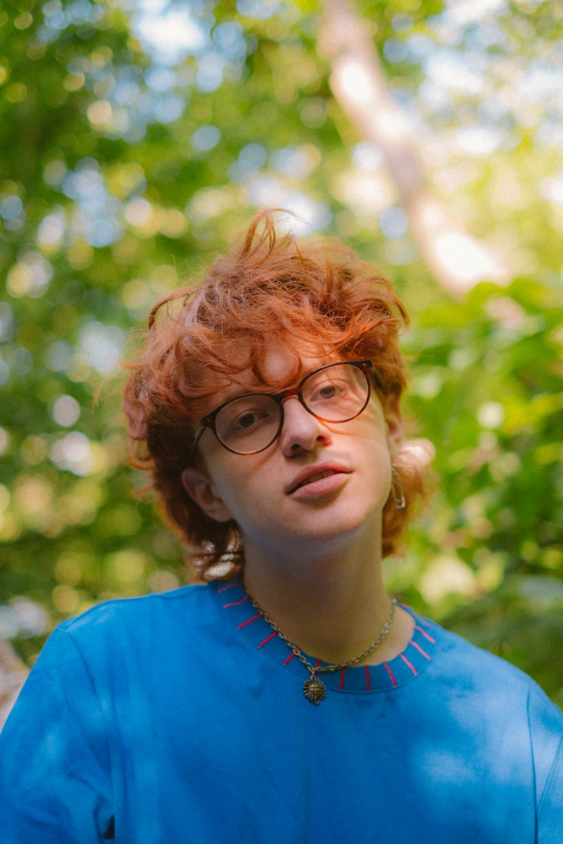

July 10, 2020 – Today, U.K. indie pop artist Cavetown shares new track “Smoke Signals,” featuring buzzing L.A.-based indie artist Tessa Violet. An official video for “Smoke Signals” is also out today, which was directed by Chad Huff [RVCA, Vans] and shot entirely on Super8mm film. Each artist filmed their part of the video in their respective home country to abide by COVID safety guidelines, with Cavetown in Queen’s Woods and Highgate Wood in the U.K. and Tessa in Joshua Tree, California.

Watch Video for “Smoke Signals” (feat. Tessa Violet) HERE
Listen to “Smoke Signals” (feat. Tessa Violet) HERE

“Smoke Signals” is the latest collaboration from Cavetown – real name Robin Skinner – following his version of “Was It Something I Said” with DIY labelmate MyKey, which was named in Billboard’s “10 Cool New Pop Songs To Get You Through The Week.” He also recently co-wrote and produced mxmtoon’s critically-acclaimed 2019 album, The Masquerade and worked with Chloe Moriondo. Earlier this year, Cavetown released his major label debut album, SLEEPYHEAD on Sire Records, featuring single “Sweet Tooth.”

On Monday, Cavetown launches “Cave Collective,” a limited edition genderless clothing line designed entirely by Robin, featuring creative clothes for every body. Cavetown has always been known for creative and practical merch items, from socks to water bottles to cozy sweats and even kazoos, so having his own clothing line is a natural next step. He explains, "I’ve always wanted to design clothes and I finally have a great team around me to help it become a reality. I’d love for people to feel cool and interesting and comfy when they wear these clothes." Starting Monday, July 13, Edition 01 of Cave Collective is available in very limited quantities at caveco.store

More about Cavetown
Since launching Cavetown at age 14, the 21 year-old UK-based singer has racked up 250 million Spotify plays and 1.3 million YouTube subscribers. He did so not with a viral hit or easy gimmicks, but rather pure heart, filling his YouTube channel with day-in-the-life, behind-the-scenes vignettes and covers. Coupled with his original, self-recorded music, Skinner’s unassuming-yet-captivating personality took the internet by storm, catapulting him to millions of streams and subscribers and stages around the world, including recent sold-out headline performances at venues like Los Angeles’ Fonda Theatre, New York City’s Webster Hall and London’s Shepherd’s Bush Empire, as well as Reading & Leeds and TRNSMT Festival.

More about Tessa Violet
Riding off the release of her fall 2019 debut album, Bad Ideas, Los Angeles-based independent artist and songwriter Tessa Violet has garnered millions of streams with support from the likes of The FADER, MTV, and Billboard as well as sold out U.S. and UK headline tours, support tours for AJR and COIN, and an appearance at Lollapalooza.

###

Follow Cavetown:
Press Assets | Website | Facebook | Twitter | Instagram | YouTube

Follow Tessa Violet:
Instagram | Facebook | Twitter | YouTube

For further information, contact:
Jaime Rosenberg / Jaime.Rosenberg@warnerrecords.com
Patrice Compere / Patrice.Compere@warnerrecords.com

