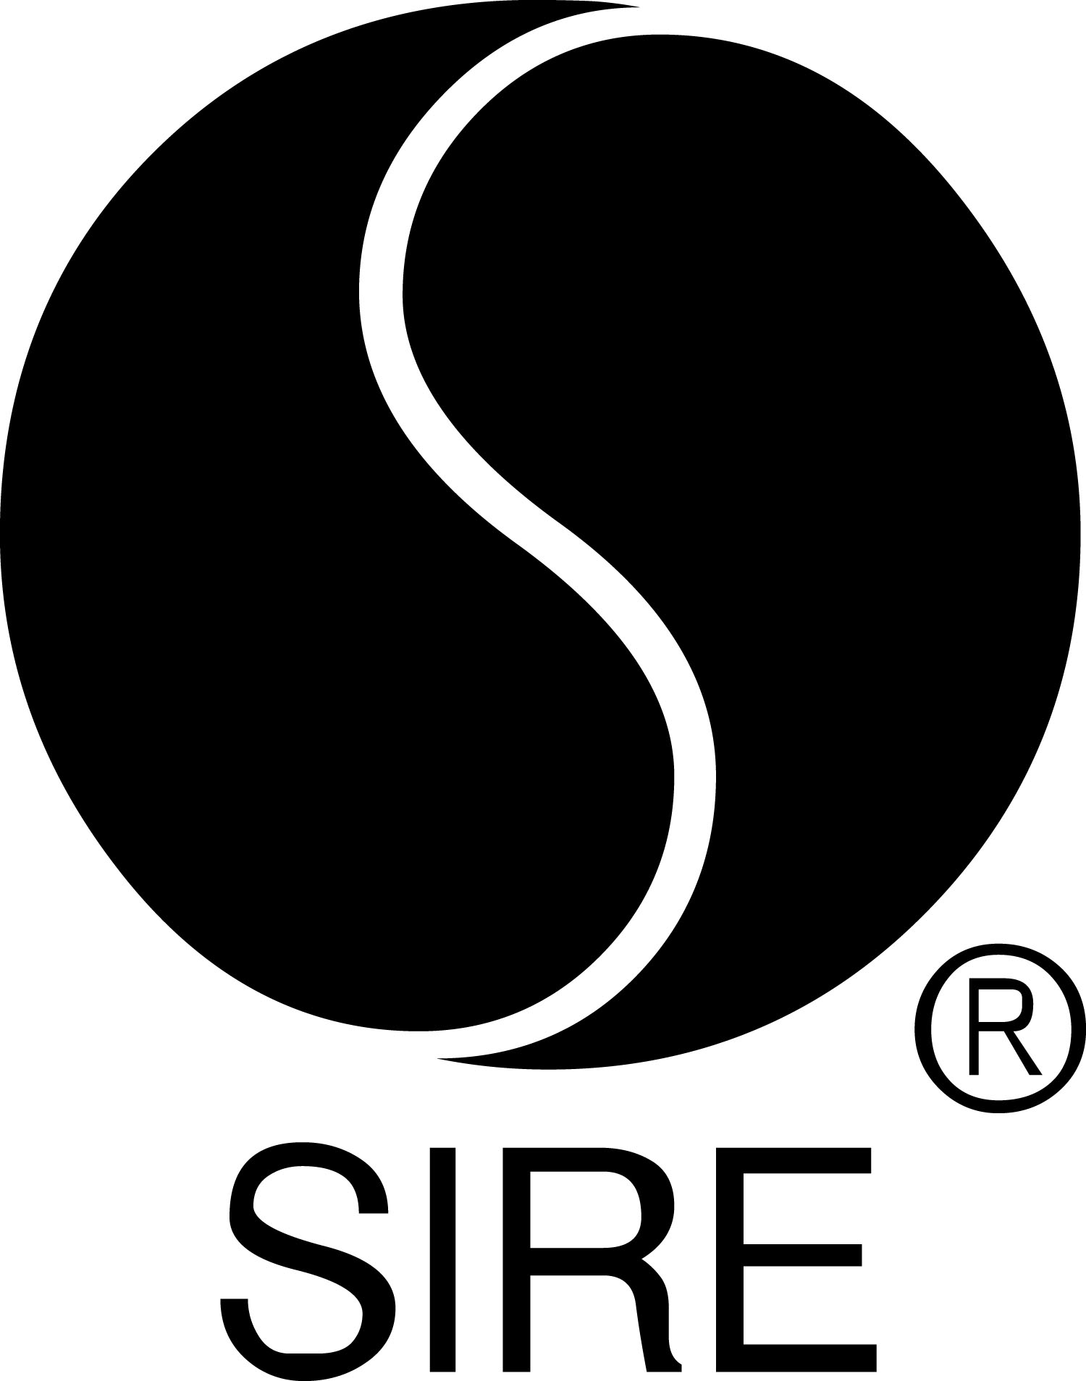

BRYCE VINE TEAMS UP WITH LOUD LUXURY FOR NEW SONG
“I’M NOT ALRIGHT”

MAJOR LABEL DEBUT CARNIVAL OUT JULY 26 ON SIRE RECORDS,
AVAILABLE NOW FOR PRE-ORDER HERE

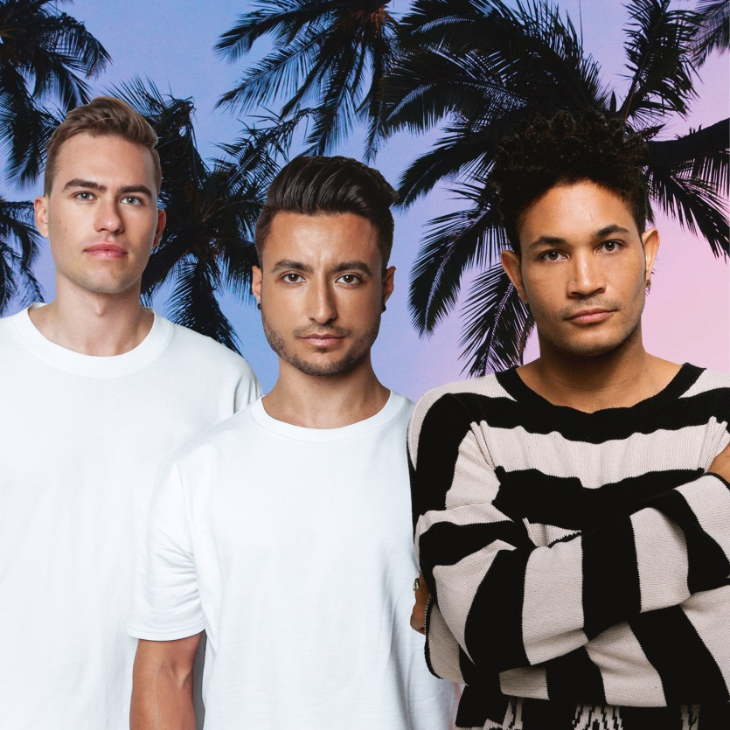

July 12, 2019 (Los Angeles, CA) — As his single “La La Land (feat. YG)” continues to rise on the U.S. charts and was recently chosen by TIME for their “Summer Party Playlist,” Bryce Vine has teamed up with renowned Canadian DJ duo Loud Luxury for new track “I’m Not Alright,” out today. Loud Luxury are fresh off the success of their Platinum single “Body” – the most played song on dance radio for all of 2018 – while “I’m Not Alright” precedes Vine’s upcoming major label debut, Carnival, out July 26 on Sire Records and available now for pre-order HERE. To celebrate Carnival’s release week, Vine is hitting the road for a string of tour dates. All dates and tickets on sale now – HERE.

Listen to Loud Luxury and Bryce Vine “I’m Not Alright” HERE

“Loud Luxury are some of my favorite dudes I’ve met in this industry,” says Bryce Vine. “They really care about the music they make, and we share a mantra of keeping life fun and exciting!”

Loud Luxury adds about the track, “At the end of the day we are all human, we all make mistakes, but this song is about coming to terms with your flaws.”

MORE ABOUT BRYCE VINE:
Bryce Vine presents a genre-bending, East Coast-meets-West Coast sound all his own, drawn in equal parts from the bass-heavy reality rap influence of his father, the bright, pop sensibility of his mother, and a childhood spent between New York and L.A. His keen blend of laid back, in-the-cut hip-hop and anthemic choruses prompted Entertainment Weekly to praise his “boundary-pushing aesthetic” and TIME to say he “sounds like the definition of cool,” while VIBE asserts, “You can’t put Bryce Vine in a box.” His major label debut Carnival will be released July 26 on Sire Records, with inspirations that run the gamut of the pop culture zeitgeist, lyrically referencing his favorite sci-fi TV shows, 90’s nostalgia and commentary on growing up in LA, while effortlessly fusing the punk spirit of Blink-182 with homages to Tupac and Outkast. Following the breakthrough success of the Platinum-certified “Drew Barrymore,” soaring to Top 15 at both Top 40 and Rhythm radio and accumulating over 270 million streams to date, Bryce Vine began 2019 with his very first sold out headline tour and “La La Land (feat. YG)” following the same trajectory as his first single. He’s performed on Late Night with Seth Meyers, the MTV VMAs pre-show, The Wendy Williams Show, and Jimmy Kimmel Live!. As Teen Vogue expressed, “[His] smooth, unpretentious performance really sold us on Bryce as a breakout star.” Bryce Vine is on tour throughout the summer, with all dates and tickets available at brycevine.com.

MORE ABOUT LOUD LUXURY:
It’s been an amazing ride for LOUD LUXURY (Andrew Fedyk and Joe De Pace). Since the Juno-Award winning duo debuted on Armada Music in late 2017 with their now worldwide smash hit “Body” (feat. brando)-- the most played song on dance radio for all of 2018--they sold platinum across the globe (7x in Canada, 3x in Australia, 2x in Switzerland and 1x in the U.K. U.S., Netherlands, Austria and more), held the #1 spot in the U.S. Mediabase Dance Airplay chart for two weeks, charted in the Top 40 of U.S. Pop radio and the U.K.’s Official Singles Chart (#4) and accumulated hundreds of millions of plays across the most popular streaming services. To date on Spotify alone the track has received over 531,000,000 plays. Its follow-up single “Love No More” (with anders) garnered 12 million streams on Spotify alone in its first month and currently sits at an impressive 86 million+ plays on the streaming platform. On top of the “Nights Like This” tour, also look for Loud Luxury to make their debut at Lollapalooza in Chicago and on the mainstage of Tomorrowland in Europe this summer alongside Parookaville, Mysteryland and a slew of other festivals, in addition to their residency plays at Hakkasan, Omnia and Wet Republic in Las Vegas.

BRYCE VINE UPCOMING TOUR DATES:
7/17 Las Vegas, NV KFRH / Flamingo GO POOL Dayclub

*7/24 San Francisco, CA Great American Music Hall ++
7/25 Sacramento, CA KSFM / K1025’s Summer Jam

*7/27 Los Angeles, CA The Fonda Theatre ++

*8/1 Washington, DC The Fillmore

*8/3 New York, NY Webster Hall

*8/4 Philadelphia, PA Theatre of Living Arts
8/24 Grand Rapids, MI Breakaway Music Festival
8/30-9/1 Seattle, Washington Bumbershoot
9/21 Las Vegas, NV iHeart Radio Music Festival Day Stage
10/5 Charlotte, NC Breakaway Music Festival
10/12 Nashville, TN Breakaway Music Festival
11/22-23 San Diego, CA Wonderfront Music Festival
*headline date
++ CARLIE HANSON TO OPEN

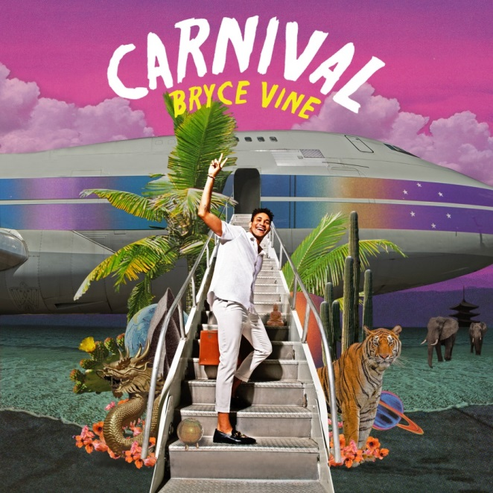

# # #

For further information on Bryce Vine, contact

Bobbie Gale at Warner Records:
818-953-3692 / Bobbie.Gale@warnerrecords.com

Ceri Roberts at Warner Records:
212-707-2259 / Ceri.Roberts@warnerrecords.com

For tour press, contact
Bre Flores at Warner Records:
818-953-3368 / Breanne.Flores@warnerrecord.com

For further information on Loud Luxury, contact

Alexandra Greenberg at Falcon Publicity:

agreenberg@falconpublicity.com

Follow Bryce Vine:
Website: https://www.brycevine.com
Facebook: https://www.facebook.com/brycevine/
Twitter: https://twitter.com/brycevine
Instagram: https://www.instagram.com/brycevine/?hl=en

Press Materials:

http://www.sirerecords.com/press/bryce-vine

