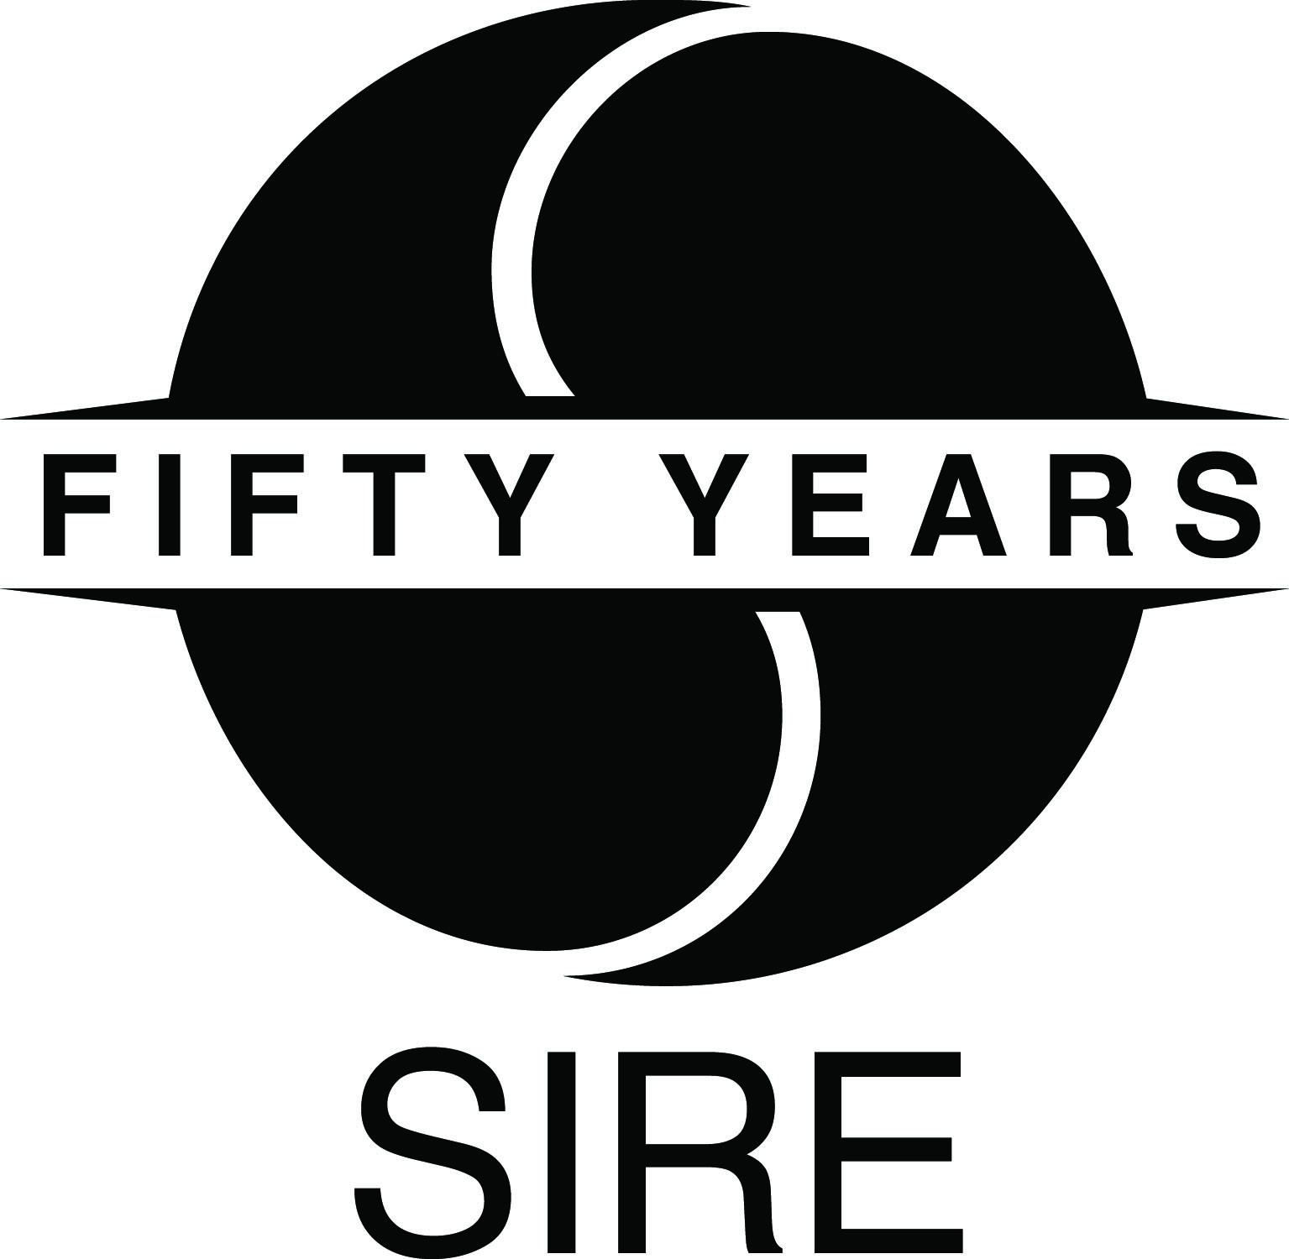

WATCH BRYCE VINE PERFORMING “DREW BARRYMORE” AT

MTV VIDEO MUSIC AWARDS PRE-SHOW HERE

“Drew Barrymore” Enters Top 20 At Top 40 And Rhythm Radio Formats

Bryce Vine Joins Pepsi’s The Sound Drop Platform
View Episode HERE

North American Tour With MAX Kicks Off October 30

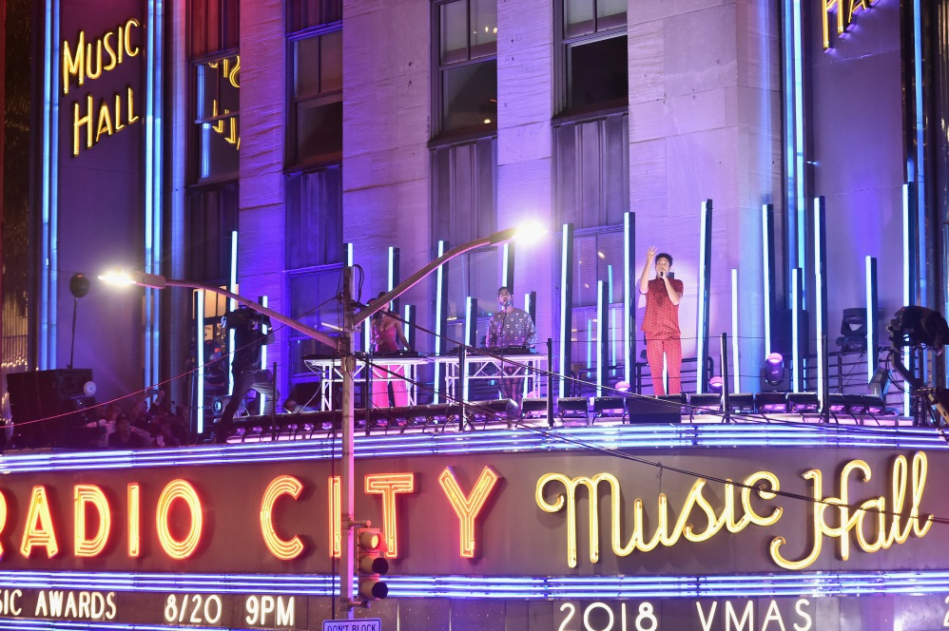

August 21, 2018 (New York, NY) — Critically acclaimed pop hip-hop maverick Bryce Vine gave a knockout performance of his breakthrough hit single “Drew Barrymore” at yesterday’s MTV Video Music Awards pre-show. View Vine’s performance here. “Drew Barrymore” has climbed into the Top 20 at both Top 40 and Rhythm radio. Cumulative streams of the track now exceed 80 million with featured playlisting in Spotify’s Today’s Top Hits and Ariana Grande’s TGIF playlist takeover this week.

Vine is the latest rising star to join Pepsi’s The Sound Drop platform. Yesterday, Billboard premiered the first episode, which can be viewed here. It includes an interview with Vine plus YouTuber Andie Case doing a cover of “Drew Barrymore.” The Sound Drop was created by Pepsi to provide emerging artists with a powerful stage to promote their stories, share their art and connect directly with new and existing fans through insightful storytelling and the amplification of their music. Previously featured artists include Alessia Cara, Bebe Rexha, Khalid, James Arthur, Jidenna, Lukas Graham, MAX and Tinashe.

On October 30, Vine will join Platinum pop powerhouse MAX as direct support on the “House of Divine: World Tour Part 1.” Tickets for the run, which will conclude at Irving Plaza in New York City on November 13, are available at brycevine.com. See below for itinerary.

Vine recently made his national television debut on Late Night With Seth Meyers. Billboard praised his “killer performance” of “Drew Barrymore” and noted, “The singer’s voice dripped with emotional honesty and tenderness on every verse and hook before giving in to the infectious combination of dynamic drums and synth beat on the chorus…” Watch Vine’s performance here.

TOUR DATES

8/25 Columbia, SC The Senate

8/31 Chicago, IL North Coast Music Festival @ Union Park

10/30 Minneapolis, MN* Fine Line Music Café

10/31 Chicago, IL* Bottom Lounge

11/1 Detroit, MI* El Club

11/2 Columbus, OH* The Basement

11/3 Pittsburgh, PA* Rex Theater

11/4 Toronto, ON* Velvet Underground

11/6 Montreal, QC* Fairmont Theatre

11/7 Boston, MA* The Sinclair

11/8 Washington, DC* 9:30 Club

11/9 Freehold, NJ Iplay America’s Event Center

11/10 Philadelphia, PA* Theatre of Living Arts

11/13 New York, NY* Irving Plaza

*supporting MAX

# # #

For further information on Bryce Vine, contact

Bobbie Gale at Warner Bros. Records publicity:
818-953-3692 / Bobbie.Gale@wbr.com

Ceri Roberts at Warner Bros. Records publicity:
212-707-2259 / Ceri.Roberts@wbr.com

Digital Assets:
View Bryce Vine’s MTV Video Music Awards pre-show performance here
Check out Pepsi’s The Sound Drop episode here
Find tour information here
Watch Vine on “Late Night With Seth Meyer” here
Stream “Drew Barrymore” here
Follow Bryce Vine:
Website: https://www.brycevine.com
Facebook: https://www.facebook.com/brycevine/
Twitter: https://twitter.com/brycevine
Instagram: https://www.instagram.com/brycevine/?hl=en

Press Materials:
http://press.wbr.com/brycevine

