

**BRYCE VINE JOINS MAX ON NORTH AMERICAN TOUR FALL 2018**

**FEATURED BY YOUTUBE AS AN “ARTIST ON THE RISE”**

**“DREW BARRYMORE” ON TRACK TO BECOME A SUMMER SMASH**

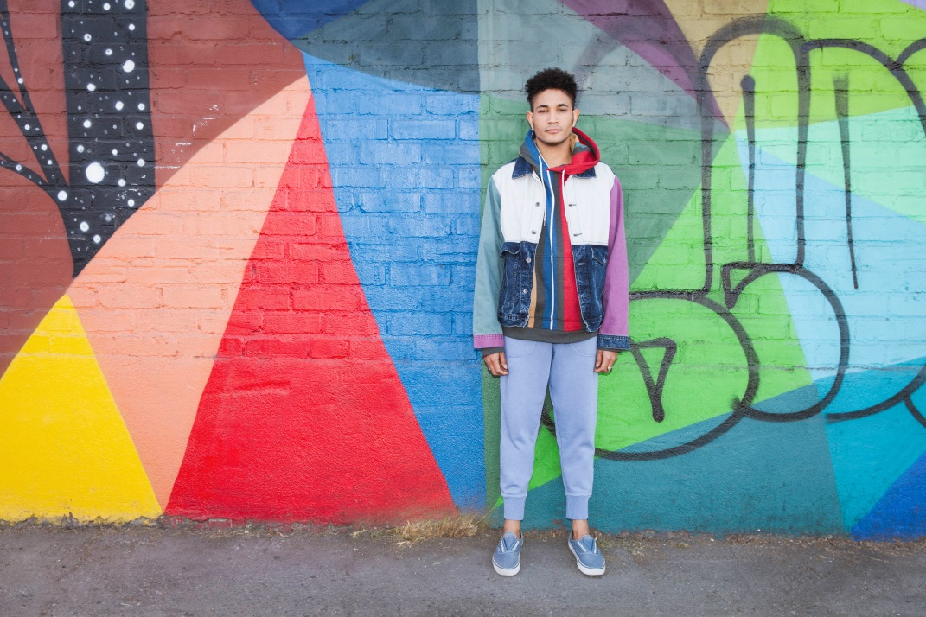

**June 26,2018 (Los Angeles, CA)** — As his breakout single “Drew Barrymore” continues to heat up, critically acclaimed pop hip-hop maverick Bryce Vine reveals extensive tour plans for 2018.

This fall, he joins platinum pop powerhouse MAX as direct support on the “House of Divine: World Tour Part 1.” He hops on the bill beginning October 30 in Minneapolis, MN through the close on November 13 in New York City. Tickets are available for pre-sale with Spotify today and go on sale to the general public on Friday, June 29 at 10:00 am local time at [brycevine.com](https://www.brycevine.com/). His full tour schedule can be found below.

Bryce Vine has quickly become synonymous with unforgettable performances and charismatic stage presence. He recently ignited the crowd at *Firefly Festival* and just last week released the live fan favorite “On The Ball.” Take a listen [here](https://brycvn.cc/ontheball).

Meanwhile, “Drew Barrymore” shows no signs of slowing down. As endearing as the actress it’s named after, the track just surpassed 17 million on Spotify, while Bryce Vine was recently featured as an “Artist On The Rise” by YouTube. Vine continues to earn fans wherever he goes, with praise from the likes of *People*, *Complex*, *TIME*, *Earmilk*, and more for what *Entertainment Weekly* describes as his “boundary-pushing aesthetic” and knack for “infusing his hip-hop tunes with an alternative feel in ways that, well, actually rock.”

Vine will be busy throughout the summer playing select gigs across the country. West Coast fans can catch him headlining School Night in Los Angeles, CA on July 9. See [brycevine.com](https://www.brycevine.com/) for further details and more upcoming shows.

**TOUR DATES**

7/9 Los Angeles, CA School Night @ Bardot

7/24 Cincinnati, OH KISS 107.1’s KISSmas in July! @ Bogart’s

8/29 Grand Rapids, MI 1045 SNX’s Party in the Park @ 5/3rd Ball Park

8/31 Chicago, IL North Coast Music Festival @ Union Park

10/30 Minneapolis, MN* Fine Line Music Café

10/31 Chicago, IL* Bottom Lounge

11/1 Detroit, MI* El Club

11/2 Columbus, OH* The Basement

11/3 Pittsburgh, PA* Club AE

11/4 Toronto, ON* Velvet Underground

11/6 Montreal, QC* L’Astral

11/7 Boston, MA* The Sinclair

11/9 Washington, DC* 9:30 Club

11/10 Philadelphia, PA* Theatre of Living Arts

11/13 New York, NY* Irving Plaza

*supporting MAX

###

**For further information on Bryce Vine, contact** **Ceri Roberts at Warner Bros. Records publicity:**

212-707-2259 / [Ceri.Roberts@wbr.com](mailto:Ceri.Roberts@wbr.com)

**Follow Bryce Vine:**

Website: <https://www.brycevine.com>

Facebook: <https://www.facebook.com/brycevine/>

Twitter: <https://twitter.com/brycevine>

Instagram: [https://www.instagram.com/brycevine/](https://www.instagram.com/brycevine/?hl=en)

**Press Materials:**

<http://press.wbr.com/brycevine>