

**BRYCE VINE DROPS NEW “DREW BARRYMORE” REMIX FEAT. WALE**

**VIDEO PREMIERES VIA *COMPLEX***

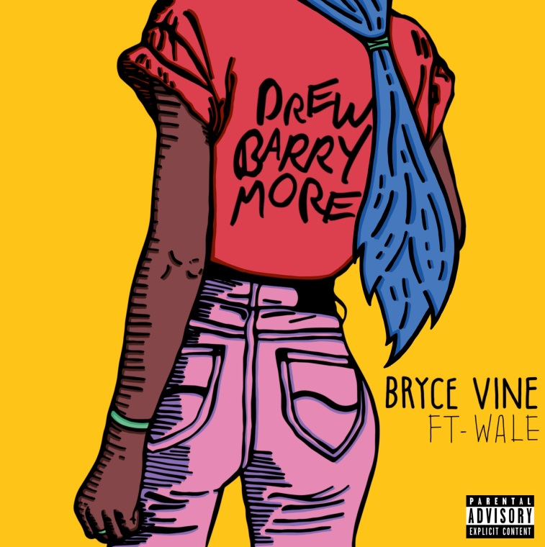

**May 11,2018 (Los Angeles, CA)** —Bryce Vine has released a new remix of his breakout single “Drew Barrymore,” featuring GRAMMY®-nominated rapper Wale. [*Complex*](http://www.complex.com/music/2018/05/bryce-vine-wale-drew-barrymore-remix-video)premiered the video for the collaboration, praising how “Wale’s guest verse definitely takes the R&B cut to a whole new level.”

**Watch the Video for “Drew Barrymore (feat. Wale)”** [**here**](https://youtu.be/4JJfOUKh9oU)

**Stream/Download “Drew Barrymore (feat. Wale)”** [**here**](https://wbr.ec/db-wale)

“Wale is a true artist,” says Vine. “I’ve been a fan for years and years. He really treated me like a little brother, joking that we were the new Martin Lawrence and Will Smith.” Wale adds simply, “Bryce Vine’s energy is uncanny.”

“Drew Barrymore” has amassed over 14 million streams on Spotify and led *Entertainment Weekly* to declare Bryce Vine as one of the “artists who will rule 2018.” Vine wrote the song with Julia Michaels and Nolan Lambroza (Sir Nolan) – who has also had hits with Selena Gomez and Justin Bieber, among others.

With over 1 million monthly listeners and over 85 million total streams on Spotify, Vine’s momentum has led to shared marquees with the likes of G-Eazy, Big Sean, and Kyle. Hailed by *Substream* as sounding “like how summer feels,” Vine has been praised by the likes of *People*, *Earmilk*, *LA Weekly*, and more for what *Entertainment Weekly* describes as his “boundary-pushing aesthetic” and knack for “infusing his hip-hop tunes with an alternative feel in ways that, well, actually rock.”

Born in Manhattan and raised in Los Angeles, Vine’s blended musical influences stretch from coast to coast. His mom, a New York City-based actress, filled their apartment with music from favorite films, while his father blasted bass-heavy “reality rap” as they flew down Los Angeles’ freeways. That duality informs Vine’s music – a keen blend of laid back, in-the-cut hip-hop and anthemic choruses – and led him to the Berklee College of Music where he met Sir Nolan. Their first collaboration, Vine’s debut EP *Lazy Fair*, featured the bouncy “Sour Patch Kids,” which now has over 17 million plays on Spotify.

“I want my music to be to the listener what music was to me: I want it to make them happy, to help them out of their dark places. A place where they feel understood and yet carefree,” Vine says.

Bryce Vine will return to the road this summer with dates confirmed in Baltimore, Kansas City, Omaha, and more to be announced soon. For tickets and more information, see [brycevine.com](https://www.brycevine.com/).

###

**For further information on Bryce Vine, contact** **Ceri Roberts at Warner Bros. Records publicity:**

212-707-2259 / [Ceri.Roberts@wbr.com](mailto:Ceri.Roberts@wbr.com)

**Digital Assets:**

Watch “Drew Barrymore (feat. Wale)” video [**here**](https://youtu.be/4JJfOUKh9oU)

Stream/Download “Drew Barrymore (feat. Wale)”[**here**](https://wbr.ec/db-wale)

**Follow Bryce Vine:**

Website: <https://www.brycevine.com>

Facebook: <https://www.facebook.com/brycevine/>

Twitter: <https://twitter.com/brycevine>

Instagram: <https://www.instagram.com/brycevine/?hl=en>

**Press Materials:**

<http://press.wbr.com/brycevine>