RELEASES NEW SINGLE “BABY GIRL”
PRODUCED BY CHAD HUGO + SIR NOLAN

LISTEN HERE
WATCH VIDEO HERE

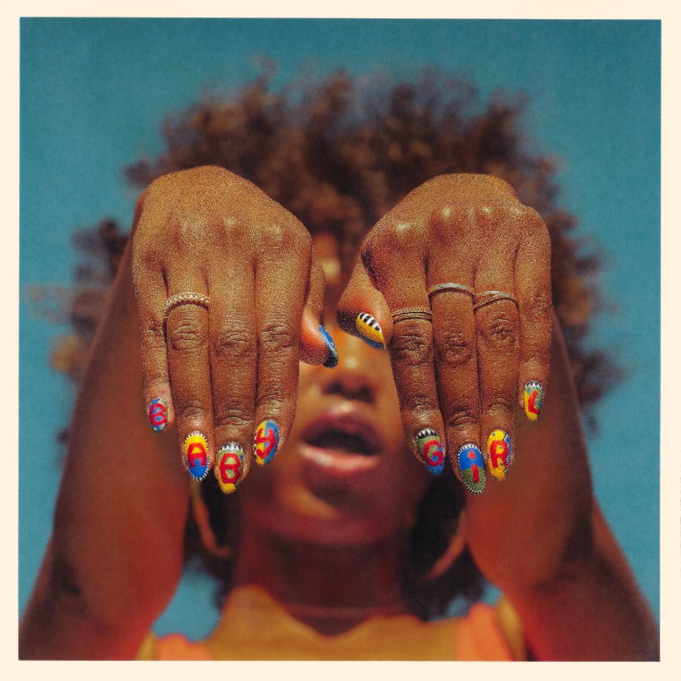

February 28, 2020 (Los Angeles, CA) – Multiplatinum Bryce Vine has shared his hotly anticipated new single “Baby Girl.” Inspired by a night out in Miami, “Baby Girl” was produced by the GRAMMY-winning legend Chad Hugo [of The Neptunes and N.E.R.D.] alongside Bryce Vine’s longtime collaborator Sir Nolan [Selena Gomez, Justin Bieber, Alec Benjamin]. Also dropping today is the video for “Baby Girl” – directed by Malia James [Halsey, Tove Lo, Green Day], the vibrant visual transports you into an old school block party. Watch here!

Bryce elaborates, “I was in Miami at a club, which is rare for me, and I realized I didn’t have a ‘club song’ – something that people can just put on when they want to have a good time. Not everything needs to be super deep, sometimes it’s about having fun for fun’s sake, and that’s what ‘Baby Girl’ is. It’s about a girl who doesn’t need the party lifestyle, but right now that’s what she wants.”

Bryce Vine hasn’t slowed down since his breakthrough success with the 2X Platinum “Drew Barrymore,” spending 2019 on sold out headline tours across the U.S., earning further hits with the Platinum “La La Land (feat. YG)” and “I’m Not Alright” with Loud Luxury, and is now approaching 1 billion streams worldwide across his catalog. He’s performed on Late Night with Seth Meyers, Jimmy Kimmel Live!, Wendy Williams, The Kelly Clarkson Show, The Late Late Show with James Corden, and Live with Kelly and Ryan.

“Bryce Vine is the epitome of low-key cool.” TIME

“Signature smooth and smoky vocals.” BILLBOARD

“You can’t put Bryce Vine in a box.” VIBE

“All of the feel-good, roll-the-window-down vibes.” MARIE CLAIRE

“Vine has a way of being cheeky with his lyrics and play-on-words—while still making his songs romantic & instantly catchy.” ENTERTAINMENT TONIGHT

“[His] smooth, unpretentious performance really sold us on Bryce as a breakout star.” TEEN VOGUE

Photo credit: Alex Nazari

# # #

For further information, please contact Warner Records Publicity:
Ceri Roberts | (212) 707-2259
Ceri.Roberts@warnerrecords.com

Darren Baber | (818) 953-3751
Darren.Baber@warnerrecords.com

Follow Bryce Vine:
Website | Facebook | Twitter | Instagram

Press Materials:
http://www.sirerecords.com/press/bryce-vine

